**Rangkuman Belajar Laravel 8**

**Laravel 8 : #1 Intro**

**Laravel 8 : #2 Instalasi & Konfigurasi**

**Laravel 8 : #3 Struktur Folder, Routes & View**

**Laravel 8 : #4 Blade Templating Engine**

**Laravel 8 : #5 Model, Collection & Controller**

**Laravel 8 : #6 Database, Migration & Eloquent**

**Laravel 8 : #7 Post Model**

**Laravel 8 : #8 Post Category & Eloquent Relationship**

**Laravel 8 : #9 Database Seeder**

**Laravel 8 : #10 Factory & Faker**

**Laravel 8 : #11 N+1 Problem**

**Laravel 8 : #12 Redesign UI**

**Laravel 8 : #13 Searching & Pagination**

**Laravel 8 : #14 View Login & Registration**

**Laravel 8 : #15 User Registration**

**Laravel 8 : #16 User Login & Middleware**

**Laravel 8 : #17 Dashboard UI**

**Laravel 8 : #18 Create Post Form**

**Laravel 8 : #19 Validation & Insert Post**

**Laravel 8 : #20 Update & Delete Post**

**Laravel 8 : #21 Upload Image**

**Laravel 8 : #22 Preview, Update & Delete Image**

**Laravel 8 : #23 Authorization**

**Laravel 8 : #24 Upload Ke Web Hosting (GRATIS)**

**Laravel 8 : #1 Intro**

Laravel is a web application framework with expressive elegant syntax

Web Application Framework :

* Sebuah ‘kerangka’ yang didesain untuk mendukung pembangunan aplikasi web
* Menyediakan standar / cara untuk membangun aplikasi web
* Bertujuan untuk mengotomasi hal-hal umum yang biasanya dilakukan saat membangun aplikasi web
* Contohnya database library, templating engine, session management, authentication security, dll

**Fitur utama pada laravel :**

* MVC
* Templating Engine
* Artisan Console
* Eloquent ORM
* Authentication & Authorization
* Testing
* Packaging System
* Multiple File System
* Task Scheduling
* Websocket Programming

**Ekosistem Laravel :**

* Serverless Platform -> Vapor
* Server Management -> Forge
* Local Docker Env. -> Sail
* Micro Framework -> Lumen
* Dll

Website dibuat dengan Laravel :

Awwwards.com/websites/laravel

Designnya keren2, inspirasi dan inspirative

**Pre-requisite :**

* PHP Dasar
* Object Oriented PHP
* Konsep MVC

**Requirement :**

* PHP 8 or above via XAMPP
* MySQL via XAMPP
* Composer 2
* SequelPro / MySQL Workbench
* GitBash
* Visual Studio Code, extensions :
  + PHP Intelephense
  + Laravel Artisan
  + Laravel Snippets
  + Laravel Blade Snippets
  + Laravel Blade Spacer
  + Laravel Goto View

**Laravel 9 : #2 Instalasi & Konfigurasi**

**Syarat harus sudah ada :**

* PHP 8
* Composer

Cek apakah sudah terinstall :

**Php -v** Kalau belum terinstall, install paling gampang pakai **XAMPP**, min php versi 8

**Composer -V (huruf besar)** Kalau belum terinstall, instal dari **get-composer.org**

Kalau pakai laravel folder projectnya tidak harus di htdocs seperti php native

Create folder di D:\Applications

Dari folder application klik kanan pilih open git bash here

**Cara #1 Install laravel via composer :**

Untuk create project ketik :

**Composer create-project laravel/laravel coba-laravel**

Ls untuk menampilkan isi folder

**Cd coba-laravel**

Kemudian bisa menjalankan lokal development server laravel dengan :

**Php artisan serve**

Di browser buka **127.0.0.1:8000**

**Cara #2 Install laravell via global :**

**Composer global require laravel/installer**

* Buka klik kanan start menu,
* System,
* about,
* advanced system setting,
* environment variables,
* system variables,
* cari path,
* edit,
* new,
* %USERPROFILE%\AppData\Roaming\Composer\vendor\bin
* Lalu ok, ok dan ok lagi

Close git bash

lalu buka lagi git bash,

cd d:\applications

**Laravel new coba2-laravel**

Jauh lebih cepat dibanding lewat composer

Masuk ke cd d:applications\coba2-laravel

Lalu ketik **php artisan serve**

Lalu di browser buka **127.0.0.1:8000**

**Valet**,

utk mengakses alamat web kita dengan nama foldernya diakhiri dengan **.test**

**Di Packagist.org** cari **valet-windows**

Install vallet via composer :

**Composer global require cretueusebiu/valet-windows**

**Valet install** klik yes, yes dan yes

**Di Network Connections :**

**Pilih yang aktif**

**Kalau pakai Ethernet pilih Ethernet**

**Kalau pakai Wifi, pilih propertiesnya yang sedang aktif wifinya**

**Jadi kalau saat aktif di Wifi di Multimedia maka setting propertiesnya hanya untuk Wifi Multimedia aja**

**Begitu juga jika pindah ke Wifi RoeangRapat@Oetama maka setting propertiesnya hanya untuk Wifi RoeangRapat@Oetama**

**Sama juga dengan Wifi-wifi lainnya. Seperti Wifi di rumah, di kafe atau di tempat lainnya.**

**Ipv4 dns dirubah jadi 127.0.0.1** **dan ipv6 dns dirubah jadi ::1**

Xampp portnya dirubah appache conf port 80 listen 80 jadi listen 8080

Server local host 80 jadi 8080

Di **d:/applications** jalankan **valet park**

Artinya semua folder yang ada di dalam folder **d:\application** akan menjadi aplikasi **Laravel**

Hanya sekali dijalankannya

Test coba-laravel.test udah bisa jalan **tanpa xampp appache dan juga tanpa php artisan serve**

**Belajar3.test** bisa jalan juga

**Laravel 9 : #3 Struktur Folder, Routes & View**

**Folder dan File Penting :**

**Folder MVC :**

**Model**  : ada di **folder app/models**

**Views** : ada di **folder resources/views**

**Controller** : ada di **folder app/Http/Controllers**

**Folder routes/web.php** untuk routes atau penjaluran untuk web pada aplikasi kita

**Folder public** tempat menyimpan aset2 statis, yang bisa diakses secara publik oleh user website kita, contoh : file css, javascript, gambar

**File .env** untuk menentukan enviroment dari aplikasi laravel seperti koneksi ke database MySQL, Database, User Name, Password dan lain sebagainya

<?php

use Illuminate\Support\Facades\Route;

*/\**

*|--------------------------------------------------------------------------*

*| Web Routes*

*|--------------------------------------------------------------------------*

*|*

*| Here is where you can register web routes for your application. These*

*| routes are loaded by the RouteServiceProvider within a group which*

*| contains the "web" middleware group. Now create something great!*

*|*

*\*/*

Route::get('/', function () {

    return view('home');

});

Route::get('/about', function () {

    return view('about');

});

Route::get('/blog', function () {

    return view('posts');

});

Jika ini dijalankan maka akan error, seperti tampilan di bawah ini :

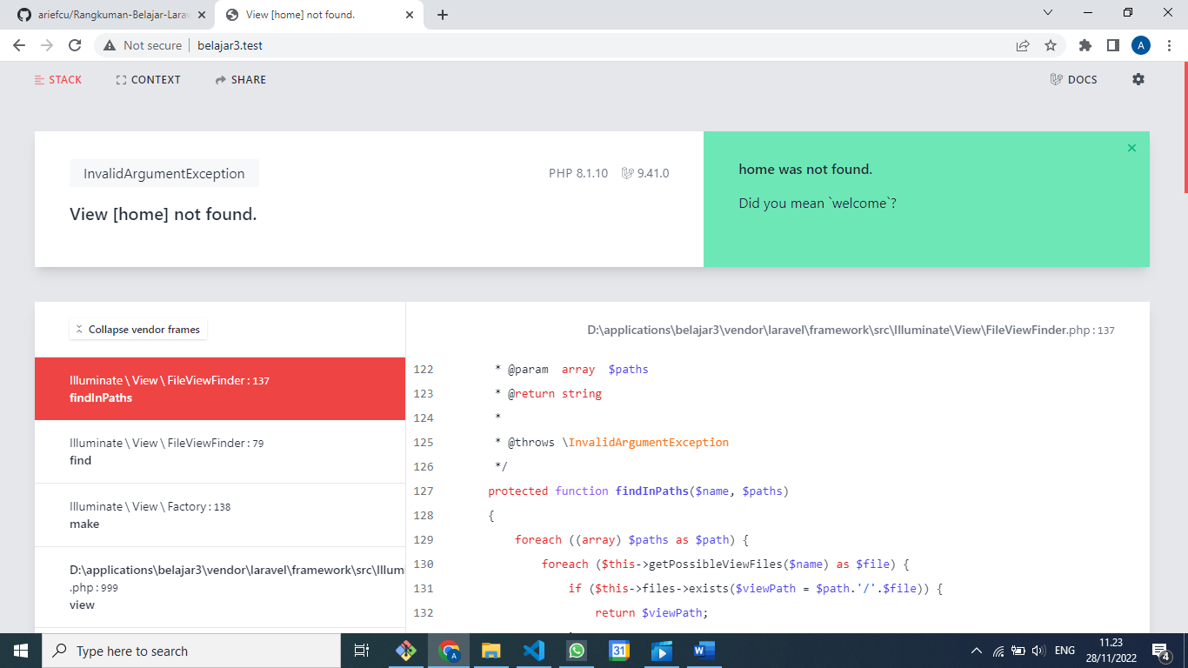

**View [home] not found.**

Lalu kita buatkan file [**home.blade.php**](http://home.blade.php) di folder resources/views

view('home');

<!DOCTYPE html>

<html lang="en">

<head>

    <meta charset="UTF-8">

    <meta name="viewport" content="width=device-width, initial-scale=1.0">

    <meta http-equiv="X-UA-Compatible" content="ie=edge">

    <title>WPU Blog | Home</title>

</head>

<body>

    <h1>Halaman Home</h1>

</body>

</html>

Setelah di save

Maka tampilannya akan seperti ini :

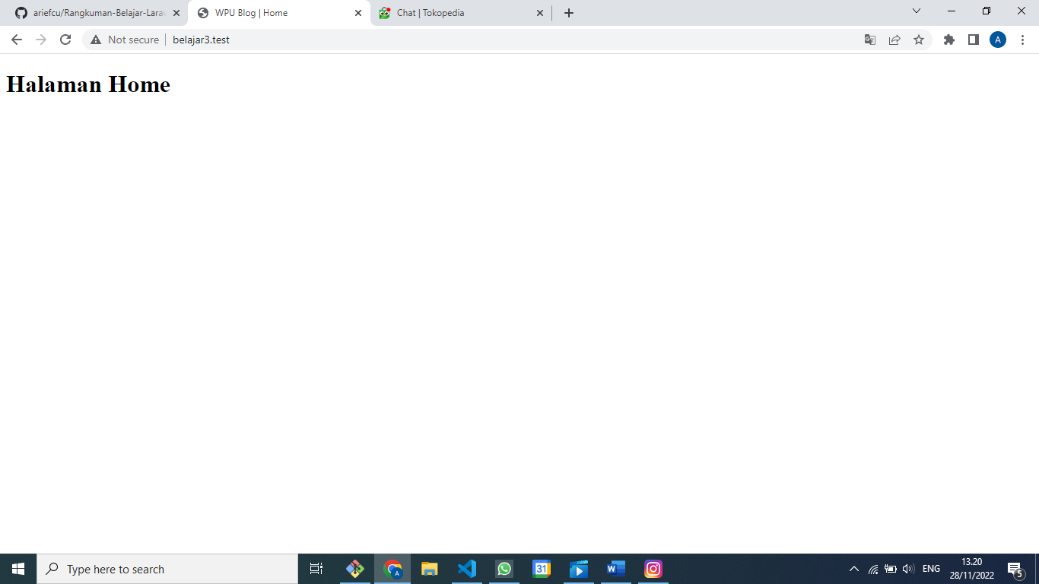

view('home');

Untuk Halaman About :

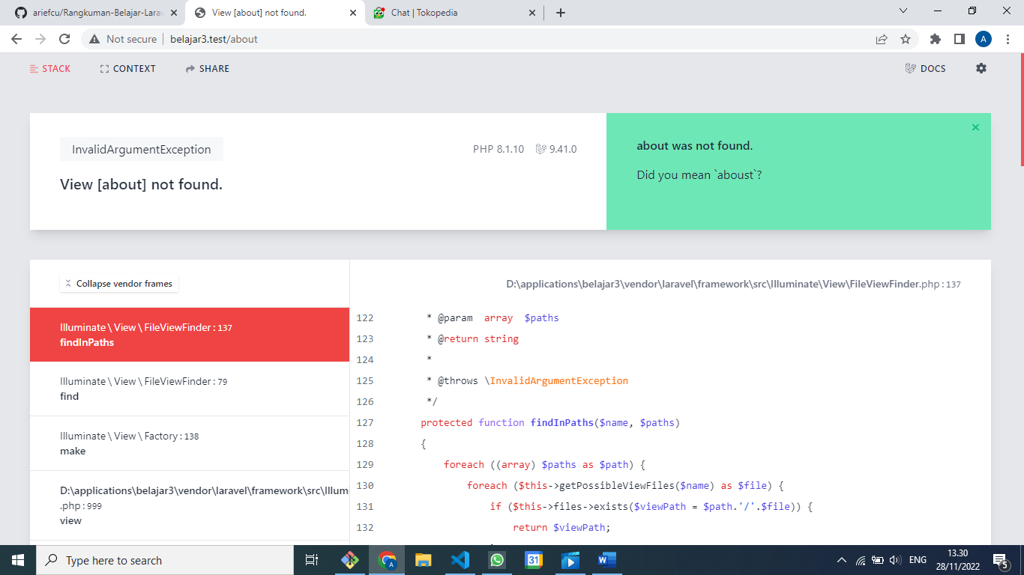

Maka harus dibuatkan file **about.blade.php** save maka tampilannya akan seperti berikut :

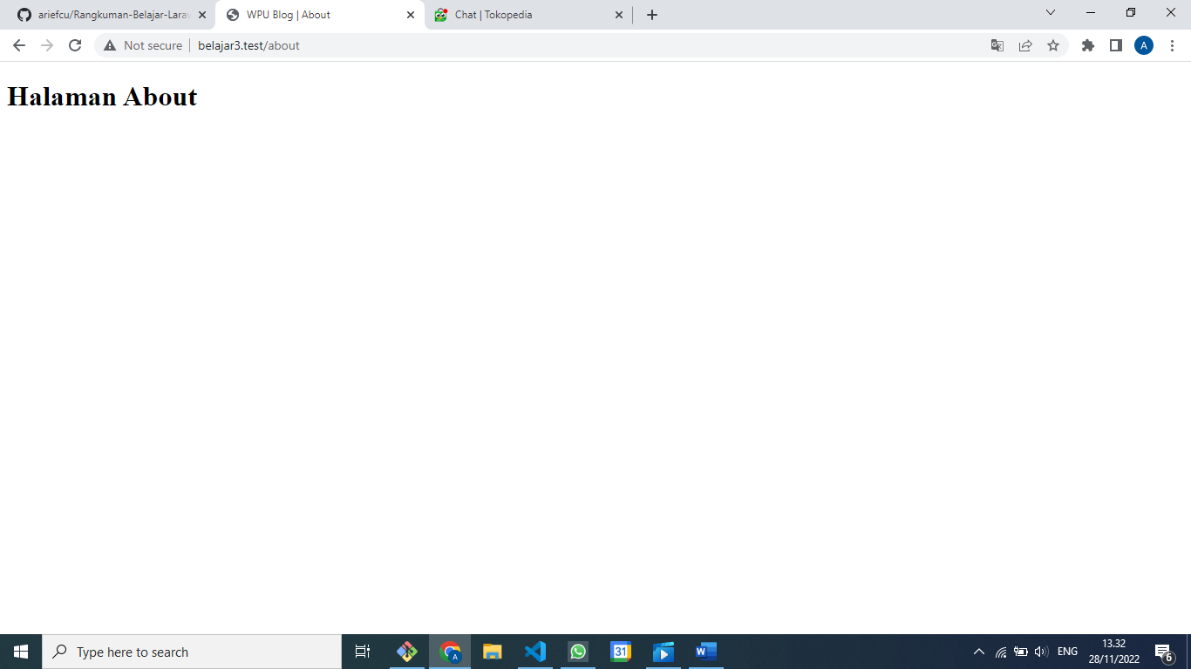

view('posts');

Begitu juga dengan Halaman Blog

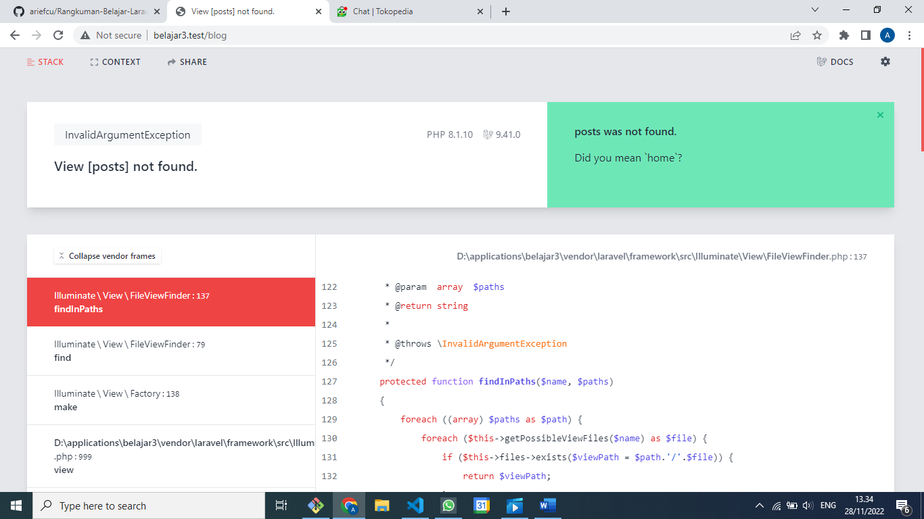

Begitu juga kita buatkan untuk posts.blade.php lalu di save maka hasilnya akan seperti berikut :

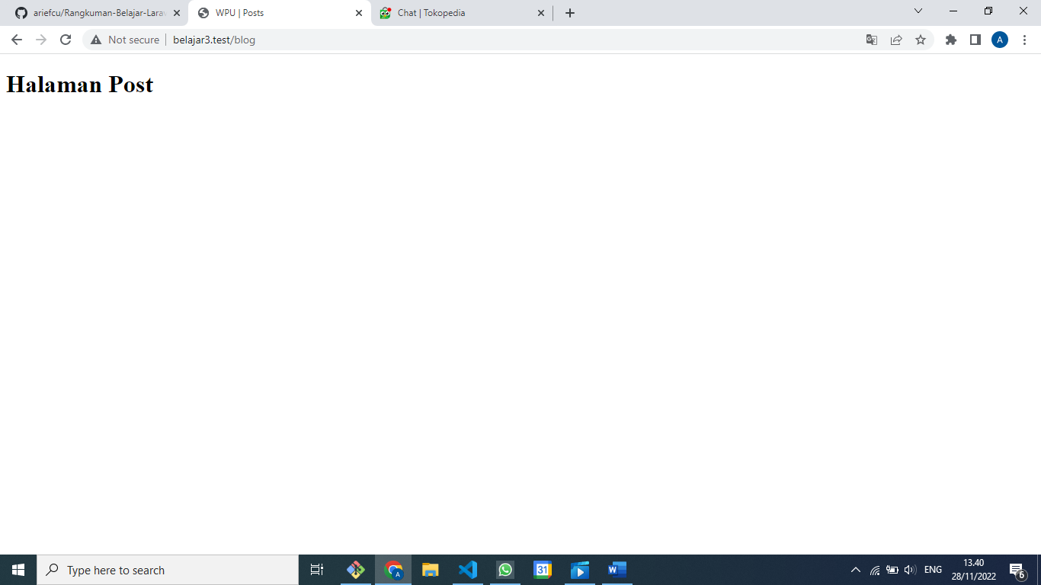

Create folder css lalu buat file style.css di folder public

body {

    background-color: salmon;

}

Lalu update file [**home.blade.php**](http://home.blade.php)

Diatas title

<link rel="stylesheet" href="css/style.css">

<!DOCTYPE html>

<html lang="en">

<head>

    <meta charset="UTF-8">

    <meta name="viewport" content="width=device-width, initial-scale=1.0">

    <meta http-equiv="X-UA-Compatible" content="ie=edge">

    <link rel="stylesheet" href="style.css">

    <title>WPU Blog | Home</title>

</head>

<body>

    <h1>Halaman Home</h1>

</body>

</html>

Create file javascript/script.js di folder public maka akan terbentuk foldr javascript dan file script.js

Ketik di bawah ini lalu save

alert("hello WPU!");

<!DOCTYPE html>

<html lang="en">

<head>

    <meta charset="UTF-8">

    <meta name="viewport" content="width=device-width, initial-scale=1.0">

    <meta http-equiv="X-UA-Compatible" content="ie=edge">

    <link rel="stylesheet" href="css/style.css">

    <title>WPU Blog | Home</title>

</head>

<body>

    <h1>Halaman Home</h1>

<script src="js/script.js"> </script>

</body>

</html>

Hasilnya setelah di refresh seperti ini :  
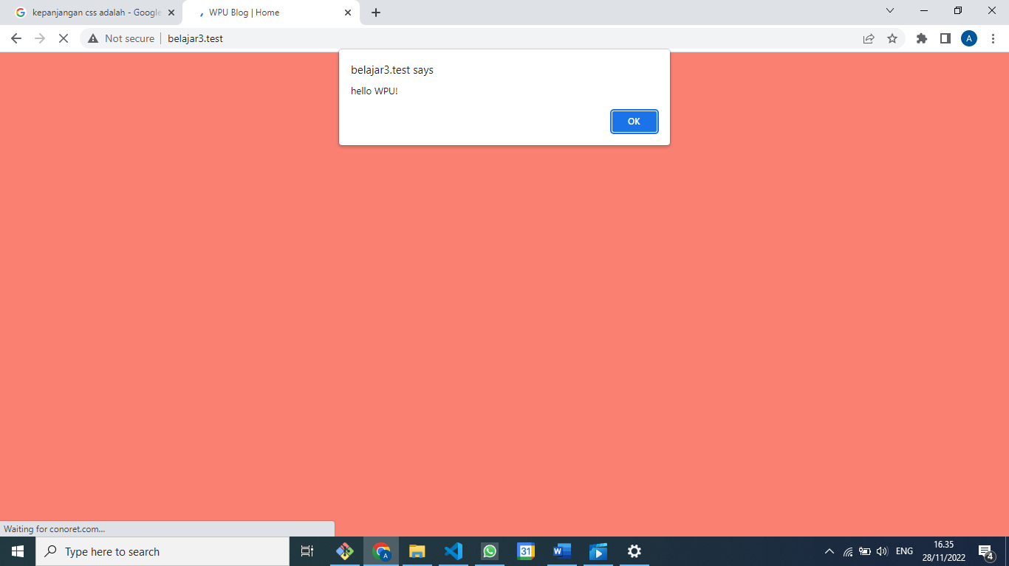

Copykan ke file **about.blade.php**

<link rel="stylesheet" href="css/style.css">

<!DOCTYPE html>

<html lang="en">

<head>

    <meta charset="UTF-8">

    <meta name="viewport" content="width=device-width, initial-scale=1.0">

    <meta http-equiv="X-UA-Compatible" content="ie=edge">

    <link rel="stylesheet" href="css/style.css">

    <title>WPU Blog | About</title>

</head>

<body>

    <h1>Halaman About</h1>

</body>

</html>

Di refresh jadi seperti ini :

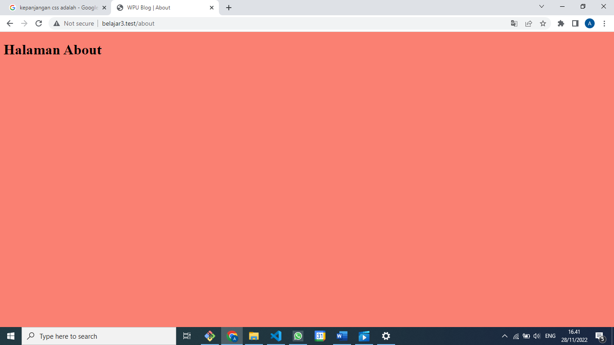

Menambahkan info nama, email dan image di Halaman About

    <h3>Arief Cahyo Utomo</h3>

    <p>ariefcu@gmail.com</p>

    <img src="img/brain.png" alt="Brain" width="200">

<!DOCTYPE html>

<html lang="en">

<head>

    <meta charset="UTF-8">

    <meta name="viewport" content="width=device-width, initial-scale=1.0">

    <meta http-equiv="X-UA-Compatible" content="ie=edge">

    <link rel="stylesheet" href="css/style.css">

    <title>WPU Blog | About</title>

</head>

<body>

    <h1>Halaman About</h1>

    <h3>Arief Cahyo Utomo</h3>

    <p>ariefcu@gmail.com</p>

    <img src="img/brain.png" alt="Brain" width="200">

</body>

</html>

Hasilnya kalau di refresh seperti ini :

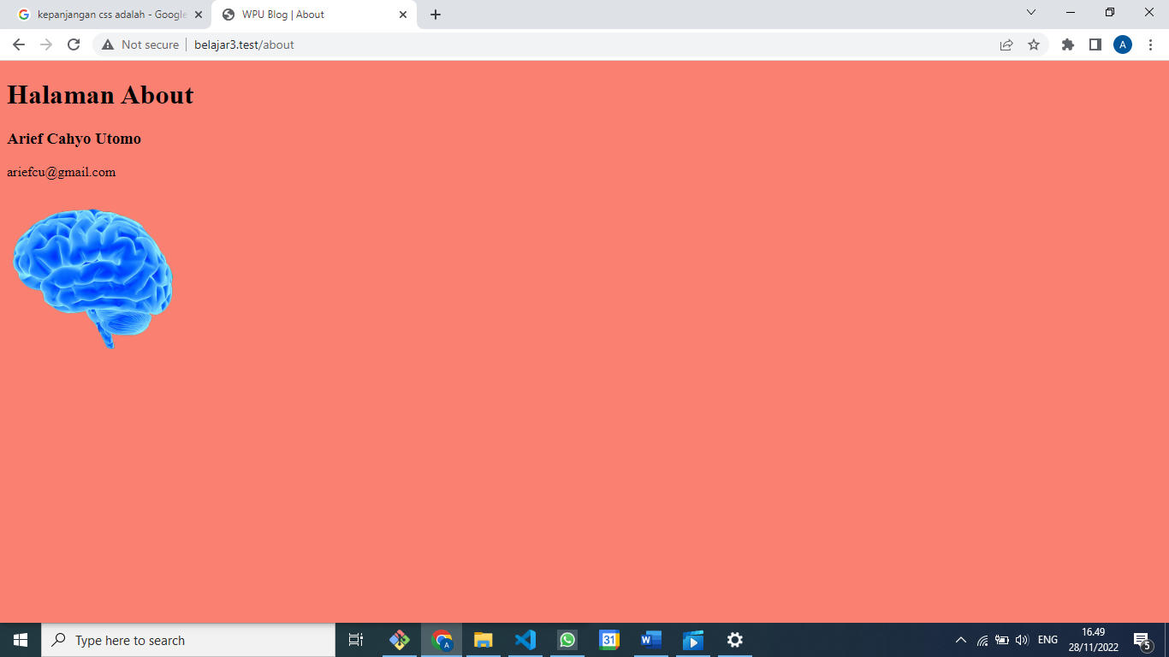

Mengirimkan data dari route kita ke view

Nama, email dan gambar, bisa kita kirim

Kerena mungkin saja data tadi berubah-rubah sesuai dengan user yang login

Kita tinggal kirimkan parameter tambahan di dalam viewnya

Cukup kasih koma (,) untuk mengirimkan datanya

Datanya bisa berupa array, karena kita akan mengirimkan nama, email dan gambar

Kita rubah di routes/web.php :

    return view('about', [

        "nama" => "Arief Cahyo Utomo",

        "email" => "ariefcu@gmail.com",

        "image" => "img/brain.png"

    ]);

<?php

use Illuminate\Support\Facades\Route;

*/\**

*|--------------------------------------------------------------------------*

*| Web Routes*

*|--------------------------------------------------------------------------*

*|*

*| Here is where you can register web routes for your application. These*

*| routes are loaded by the RouteServiceProvider within a group which*

*| contains the "web" middleware group. Now create something great!*

*|*

*\*/*

Route::get('/', function () {

    return view('home');

});

Route::get('/about', function () {

    return view('about', [

        "nama" => "Arief Cahyo Utomo",

        "email" => "ariefcu@gmail.com",

        "image" => "img/brain.png"

    ]);

});

Route::get('/blog', function () {

    return view('posts');

});

Dan juga di about.blade.php

    <h3><?= $name; ?></h3>

    <p><?= $email; ?></p>

    <img src=<?= $image; ?> alt="$name" width="200">

<!DOCTYPE html>

<html lang="en">

<head>

    <meta charset="UTF-8">

    <meta name="viewport" content="width=device-width, initial-scale=1.0">

    <meta http-equiv="X-UA-Compatible" content="ie=edge">

    <link rel="stylesheet" href="css/style.css">

    <title>WPU Blog | About</title>

</head>

<body>

    <h1>Halaman About</h1>

    <h3><?= $name; ?></h3>

    <p><?= $email; ?></p>

    <img src=<?= $image; ?> alt="$name" width="200">

</body>

</html>

Hasilnya kalau di refresh seperti ini :

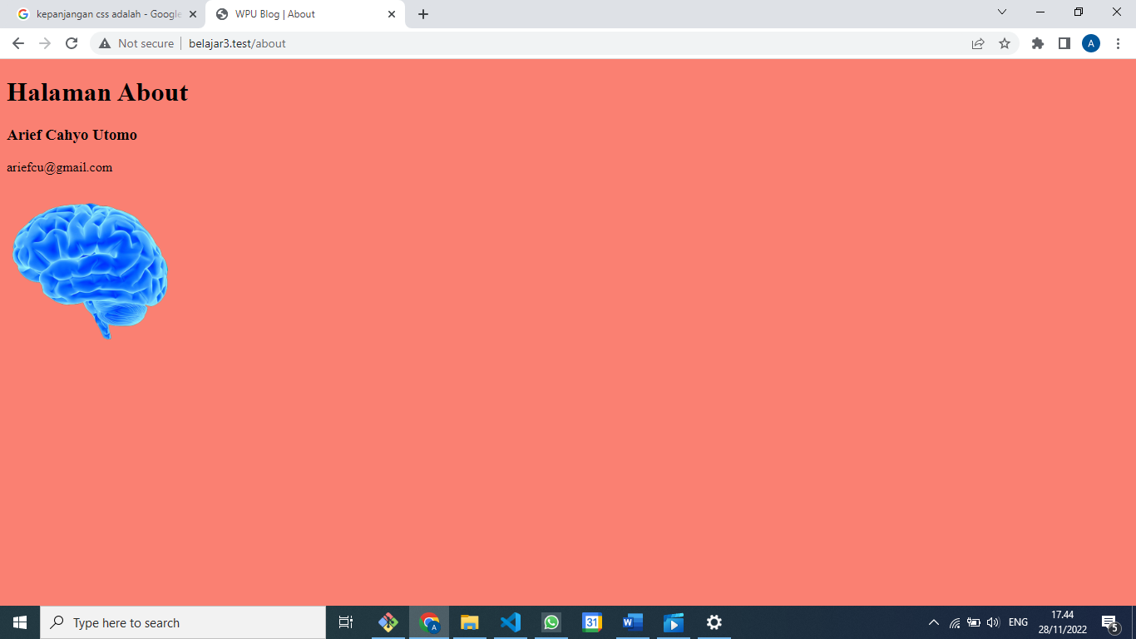

Di GitHub sebelum di sesuaikan di Gitnya :

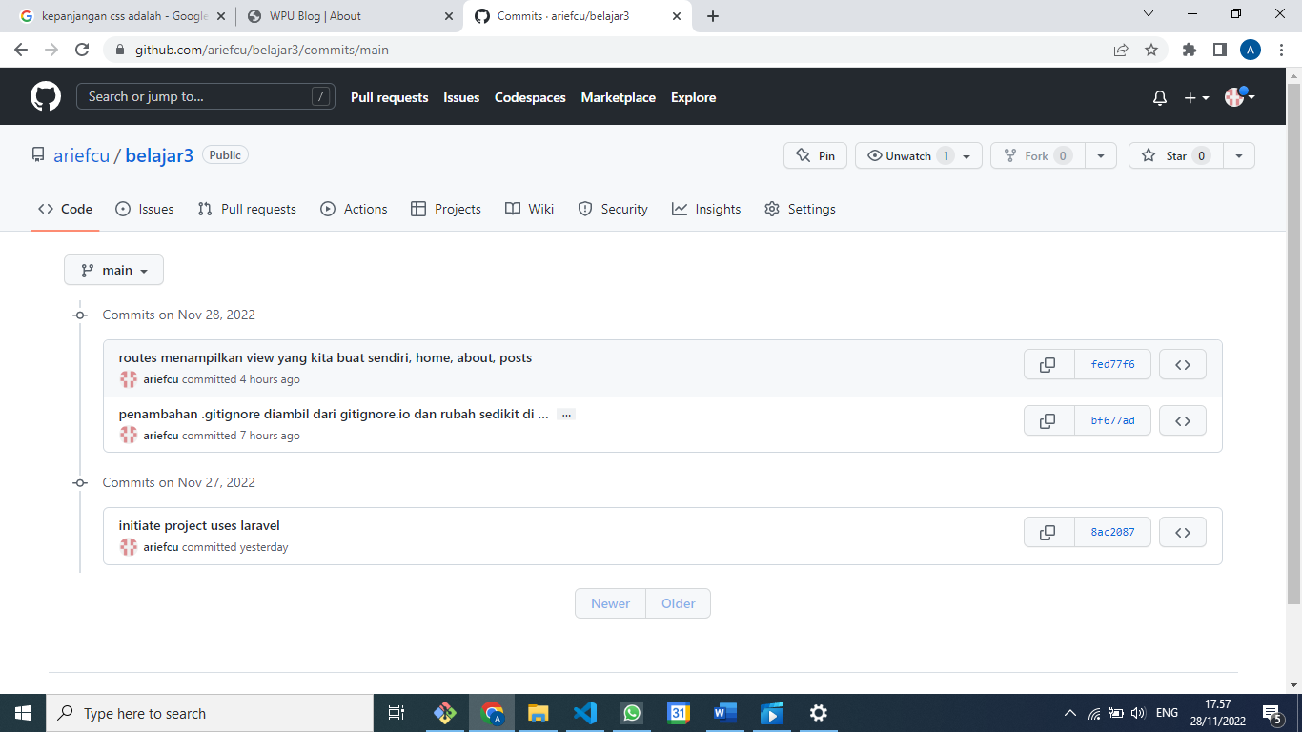

Di Git :

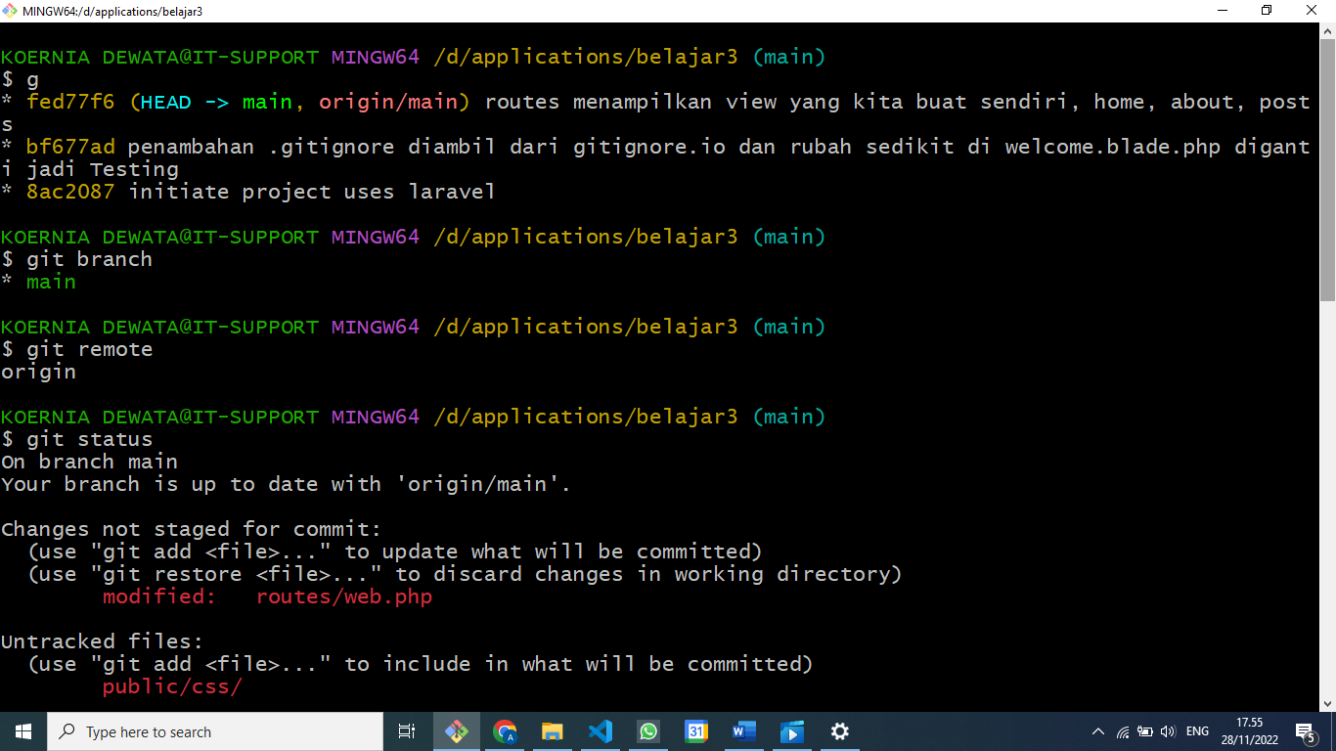

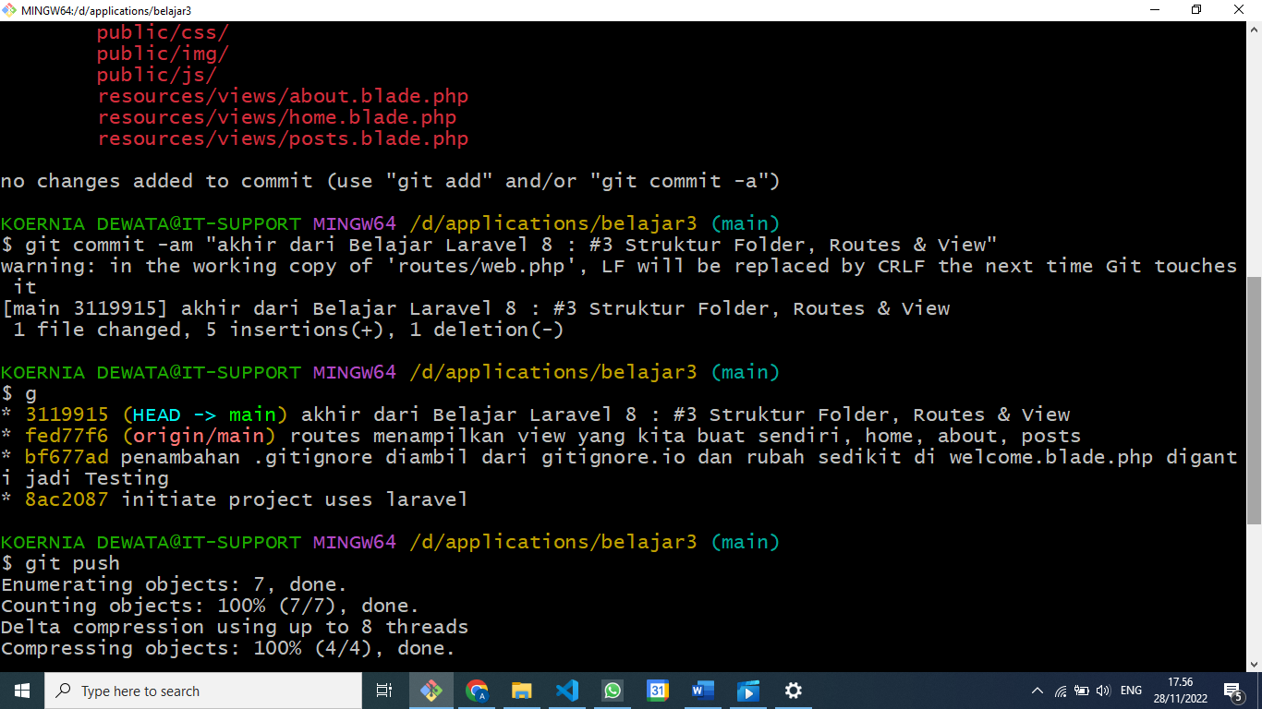

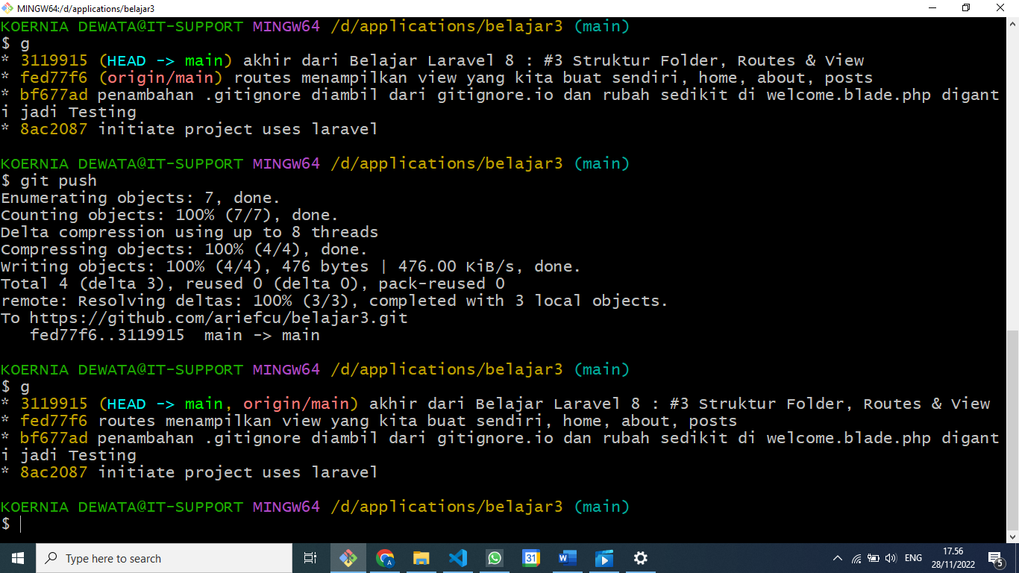

Di GitHub berubah sesuai yang ada di Git :

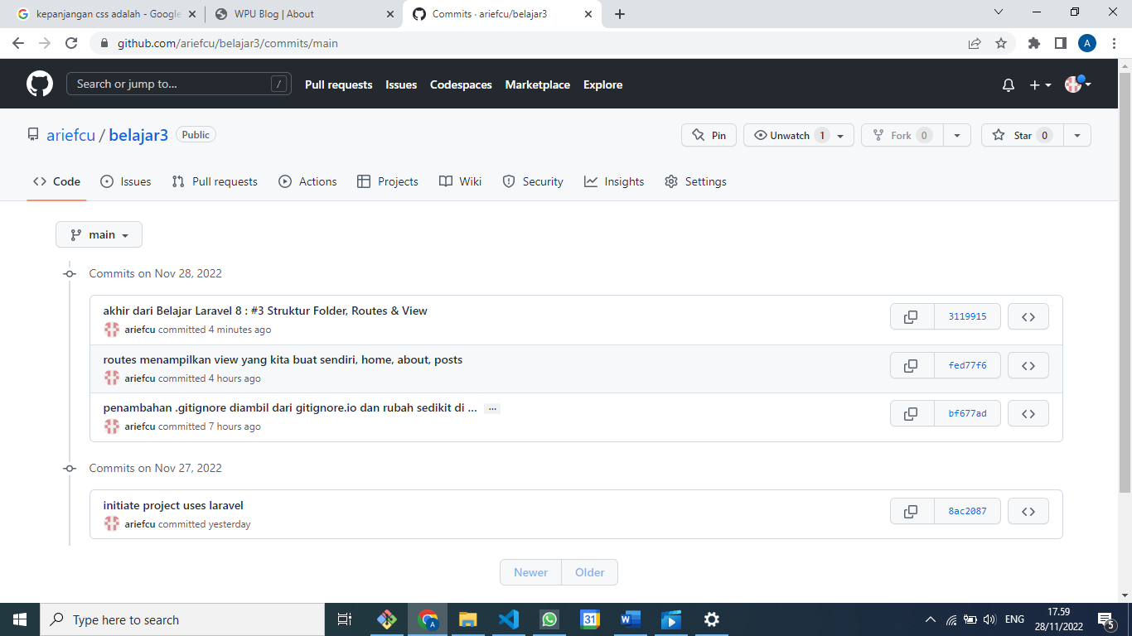

Di detilnya :

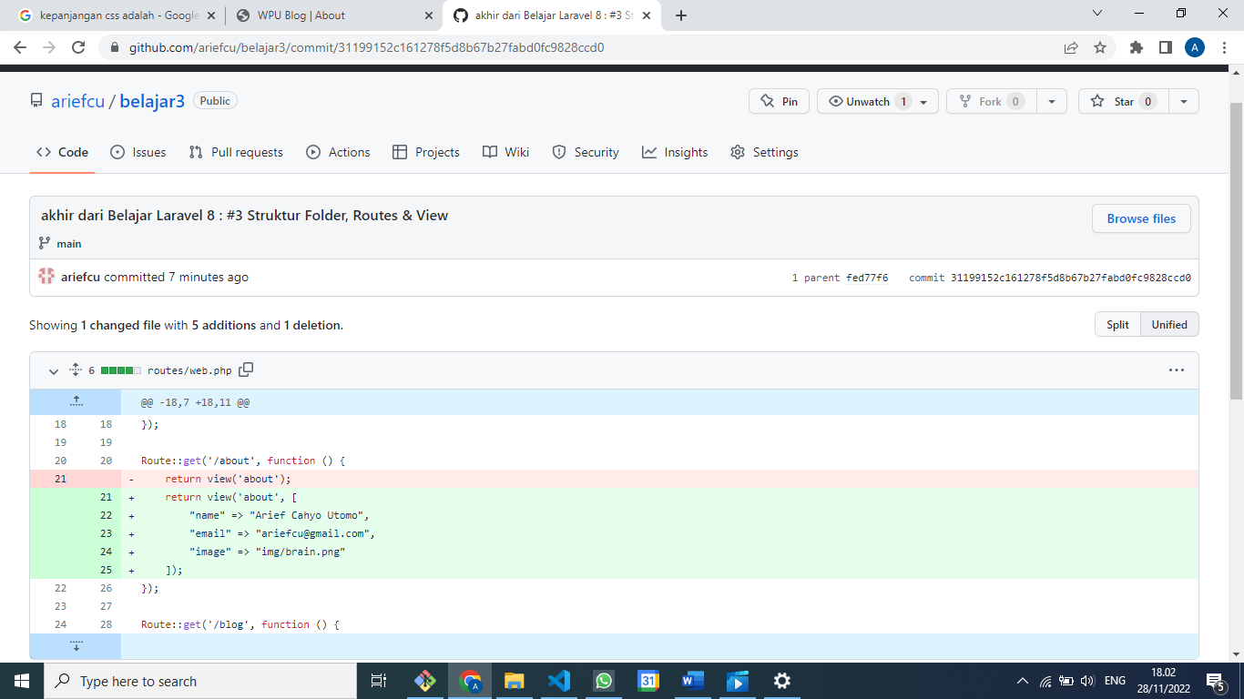

(nambah file2 dan folder2 yang tidak ikut, karena salah pakainya git commit -am, seharusnya git add .

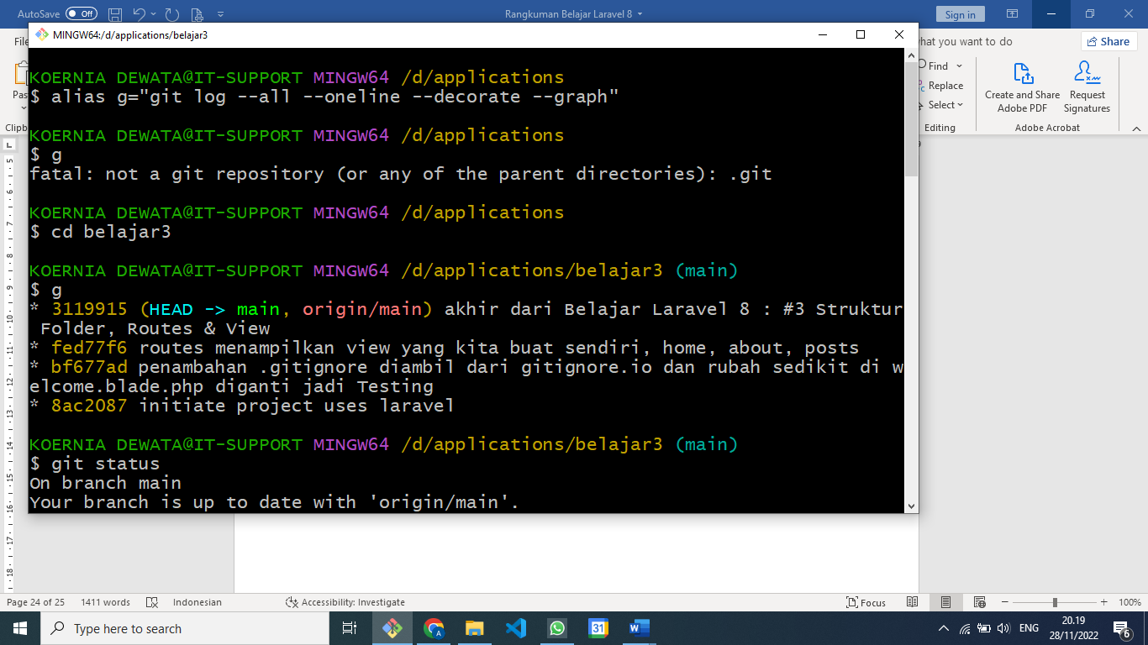

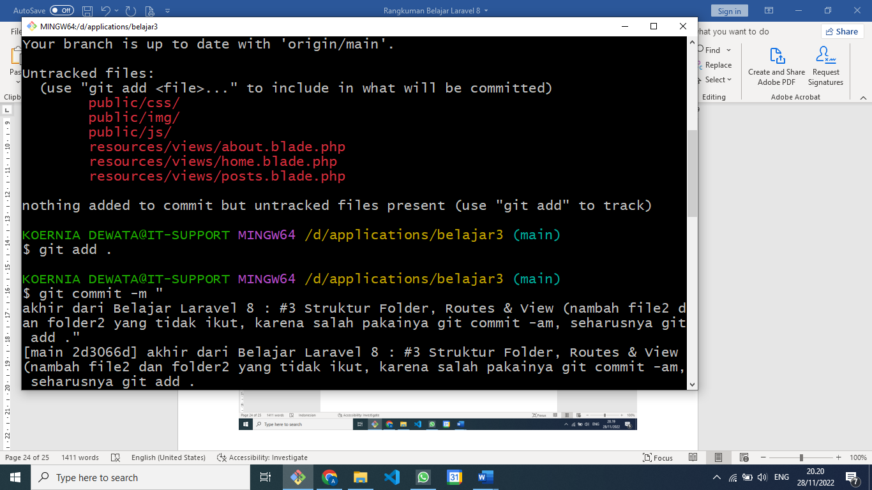

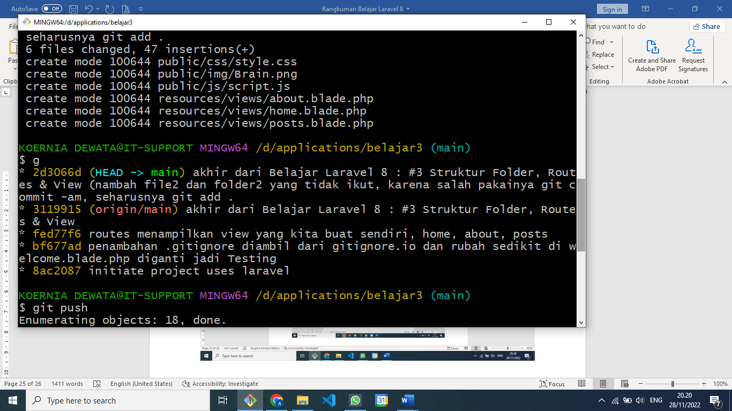

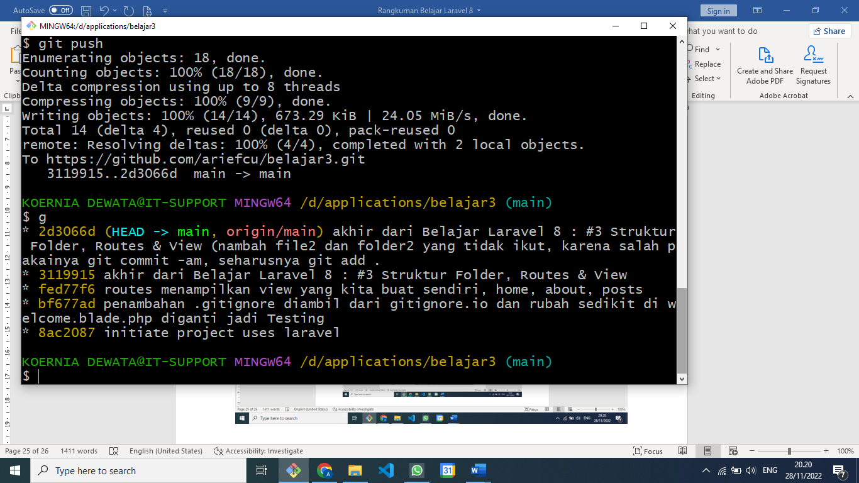

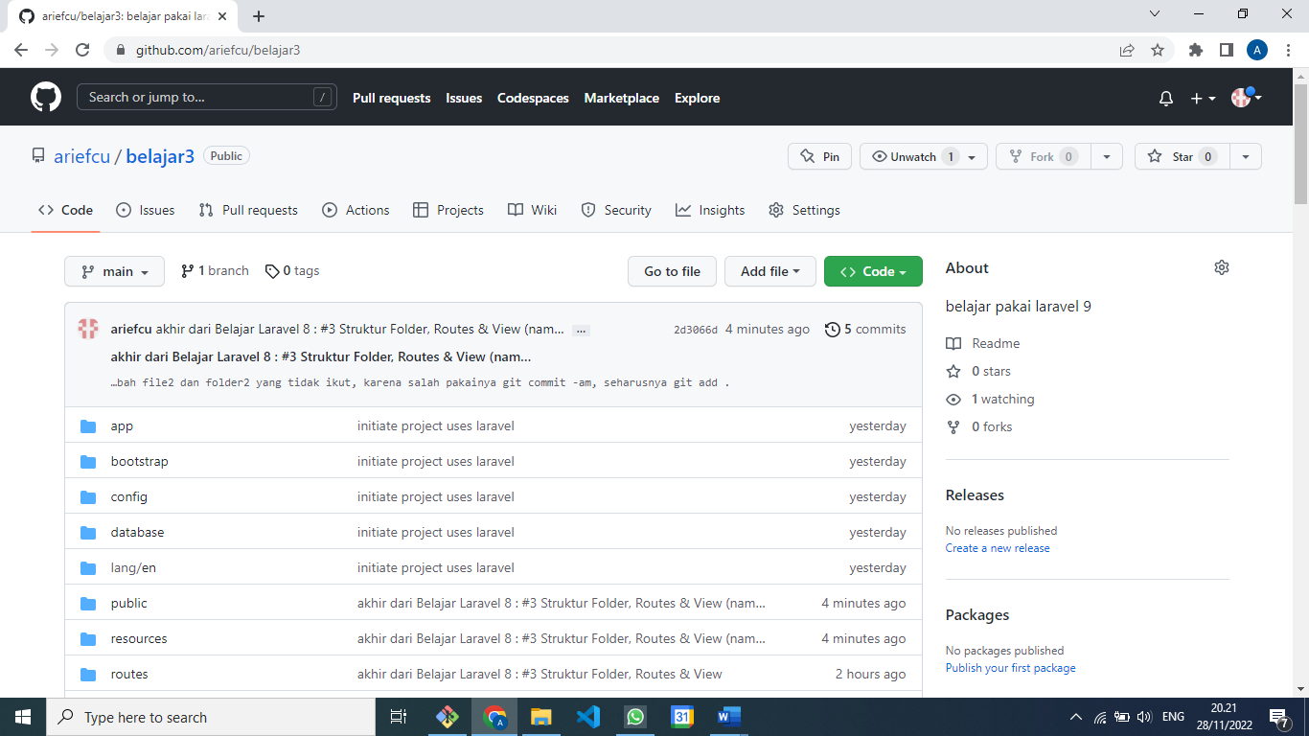

**Laravel 8 : #4 Blade Templating Engine**

Di **about.blade.php** :

    <h3><?= $name; ?></h3>

    <p><?= $email; ?></p>

    <img src=<?= $image; ?> alt="$name" width="200">

Bisa disingkat seperti ini :

    <h3>{{ $name }}</h3>

    <p>{{ $email }}</p>

    <img src={{ $image }} alt="$name" width="200">

Buka **getbootstrap.com**

Cari Starter template

Copy

<!doctype html>

<html lang="en">

  <head>

    <meta charset="utf-8">

    <meta name="viewport" content="width=device-width, initial-scale=1">

    <title>WPU Blog | Home</title>

    <link href="https://cdn.jsdelivr.net/npm/bootstrap@5.2.3/dist/css/bootstrap.min.css" rel="stylesheet" integrity="sha384-rbsA2VBKQhggwzxH7pPCaAqO46MgnOM80zW1RWuH61DGLwZJEdK2Kadq2F9CUG65" crossorigin="anonymous">

  </head>

  <body>

    <h1>Hello, world!</h1>

    <script src="https://cdn.jsdelivr.net/npm/bootstrap@5.2.3/dist/js/bootstrap.bundle.min.js" integrity="sha384-kenU1KFdBIe4zVF0s0G1M5b4hcpxyD9F7jL+jjXkk+Q2h455rYXK/7HAuoJl+0I4" crossorigin="anonymous"></script>

  </body>

</html>

Hasilnya seperti ini :

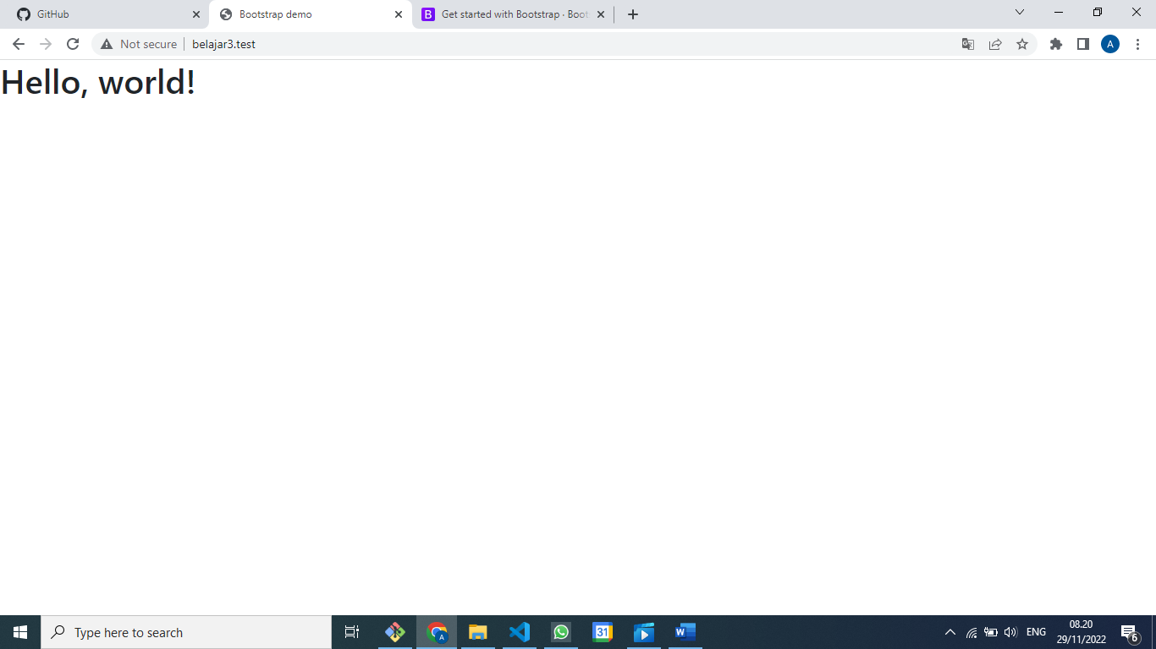

Navbar

Di boostrap.com pilih components

Lalu pilih navbar

Copykan sebelum hello, world!

    <nav class="navbar navbar-expand-lg bg-light">

        <div class="container-fluid">

          <a class="navbar-brand" href="#">Navbar</a>

          <button class="navbar-toggler" type="button" data-bs-toggle="collapse" data-bs-target="#navbarNav" aria-controls="navbarNav" aria-expanded="false" aria-label="Toggle navigation">

            <span class="navbar-toggler-icon"></span>

          </button>

          <div class="collapse navbar-collapse" id="navbarNav">

            <ul class="navbar-nav">

              <li class="nav-item">

                <a class="nav-link active" aria-current="page" href="#">Home</a>

              </li>

              <li class="nav-item">

                <a class="nav-link" href="#">Features</a>

              </li>

              <li class="nav-item">

                <a class="nav-link" href="#">Pricing</a>

              </li>

              <li class="nav-item">

                <a class="nav-link disabled">Disabled</a>

              </li>

            </ul>

          </div>

        </div>

      </nav>

Tapilannya setelah di refresh :

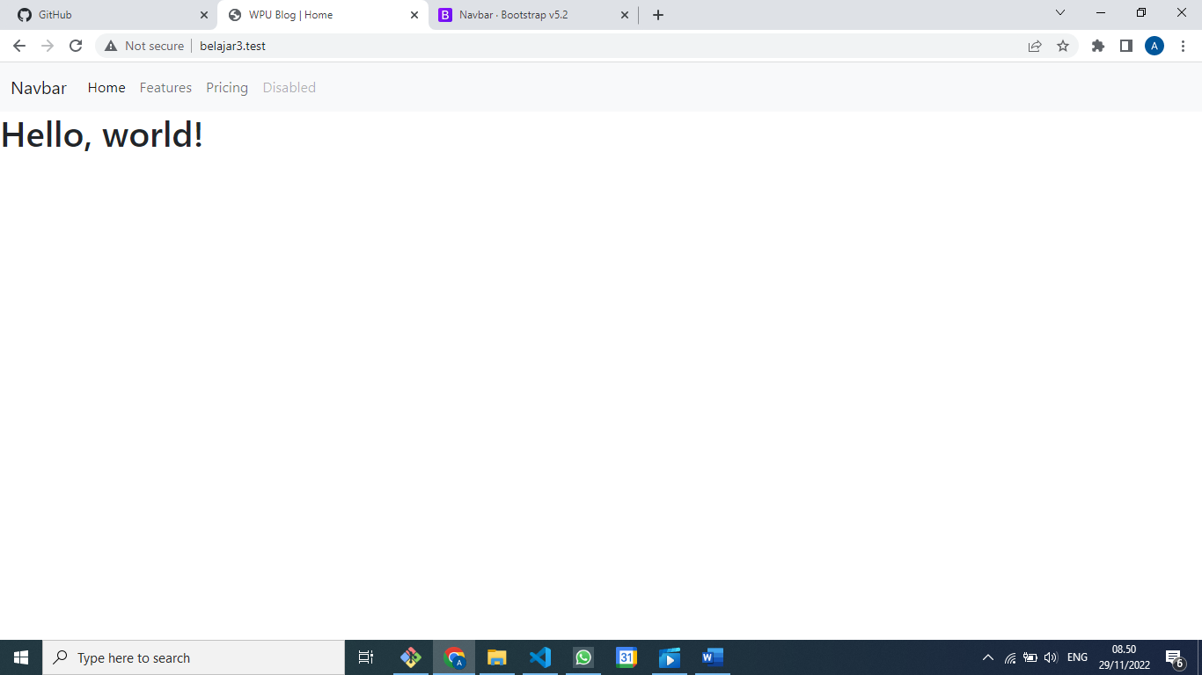

Pengen center hilangkan -fluid

        <div class="container">

Pengen warnanya merah, ganti bg-light menjadi bg-danger

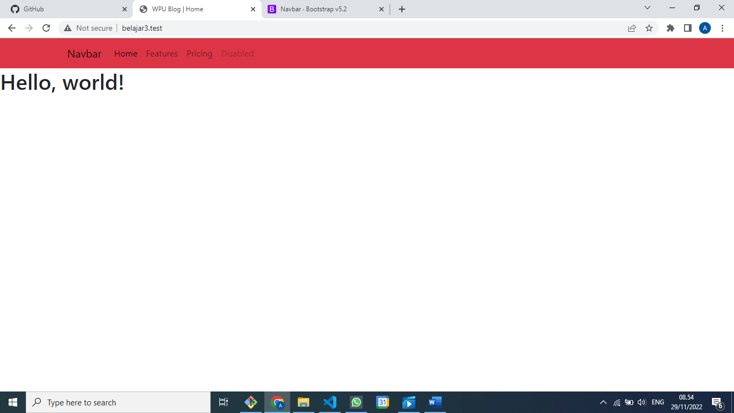

Pengen hurufnya jadi putih

    <nav class="navbar navbar-expand-lg navbar-dark bg-danger">

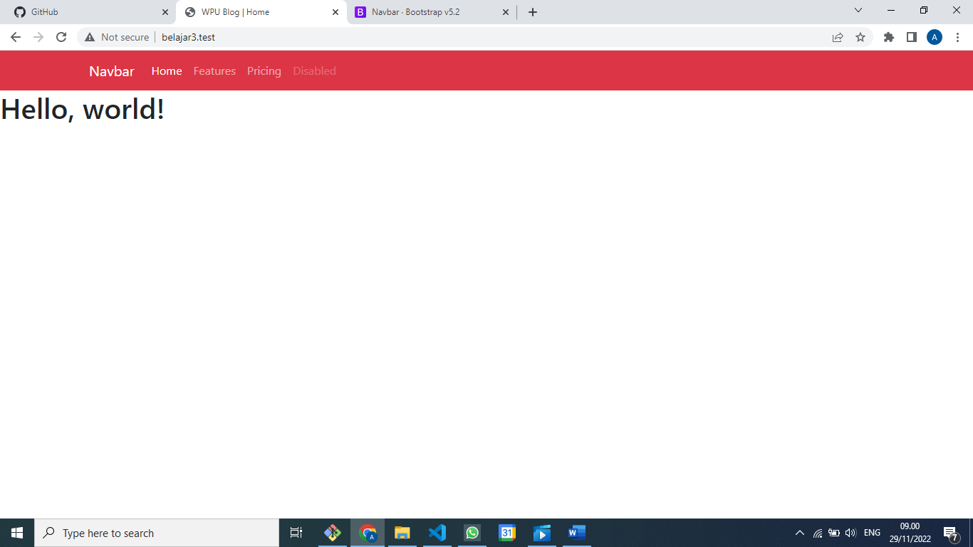

@extend

@include

@section

@yield

@foreach

Article

@dd

**Laravel 8 : #5 Model, Collection & Controller**

Belajar Model

Belajar Collection

Belajar Controller

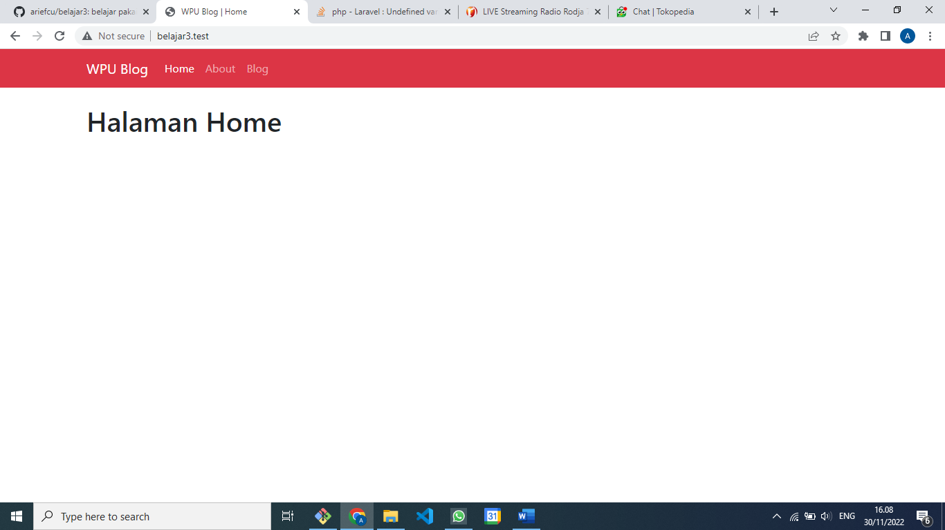

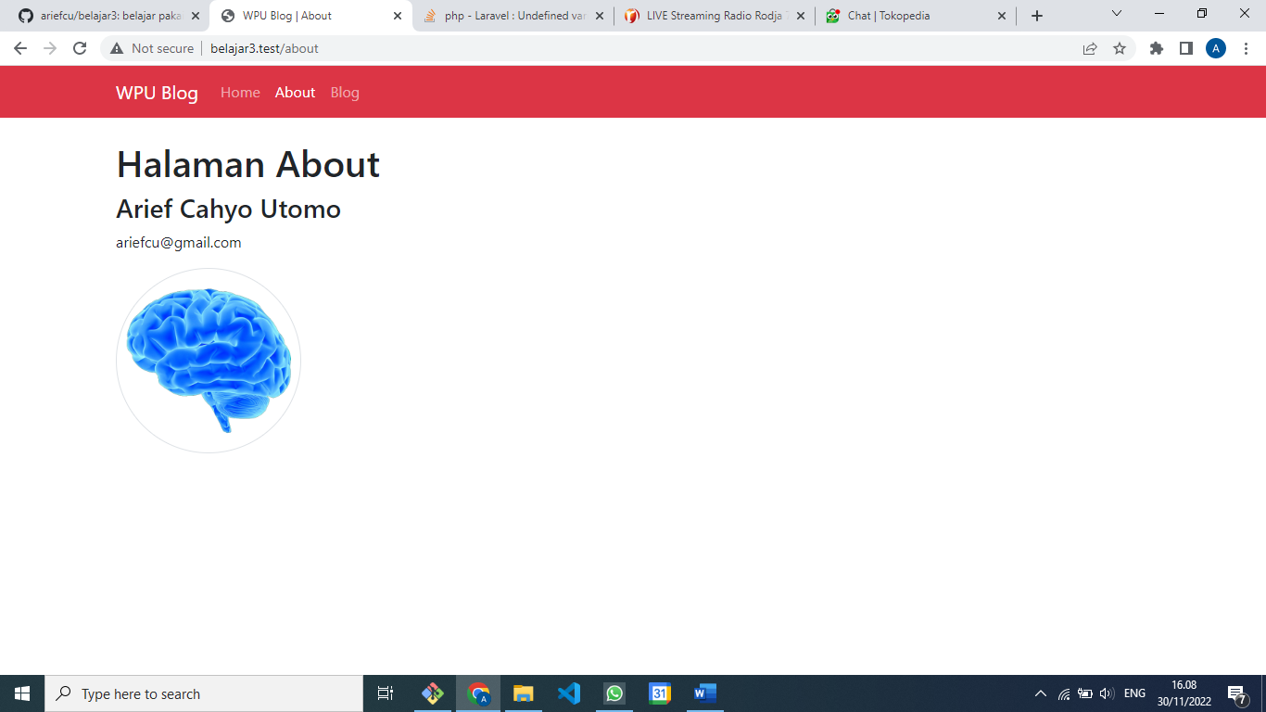

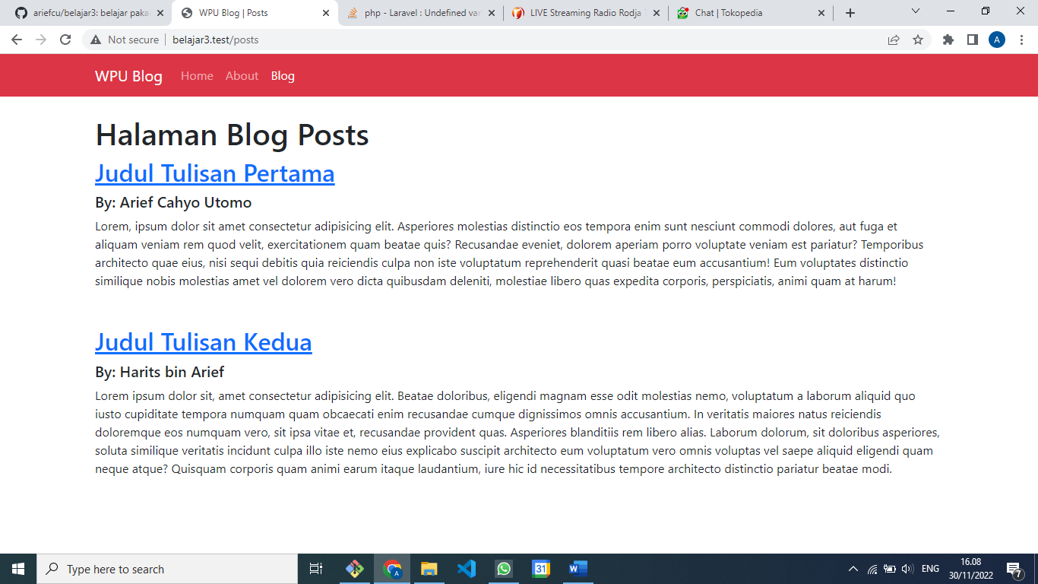

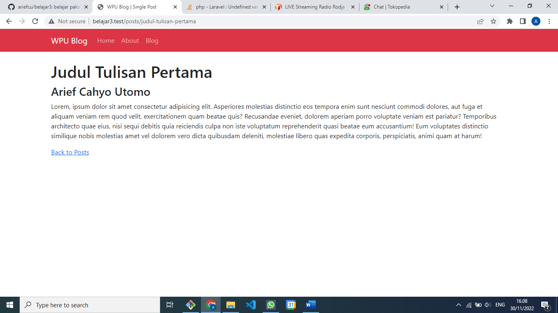

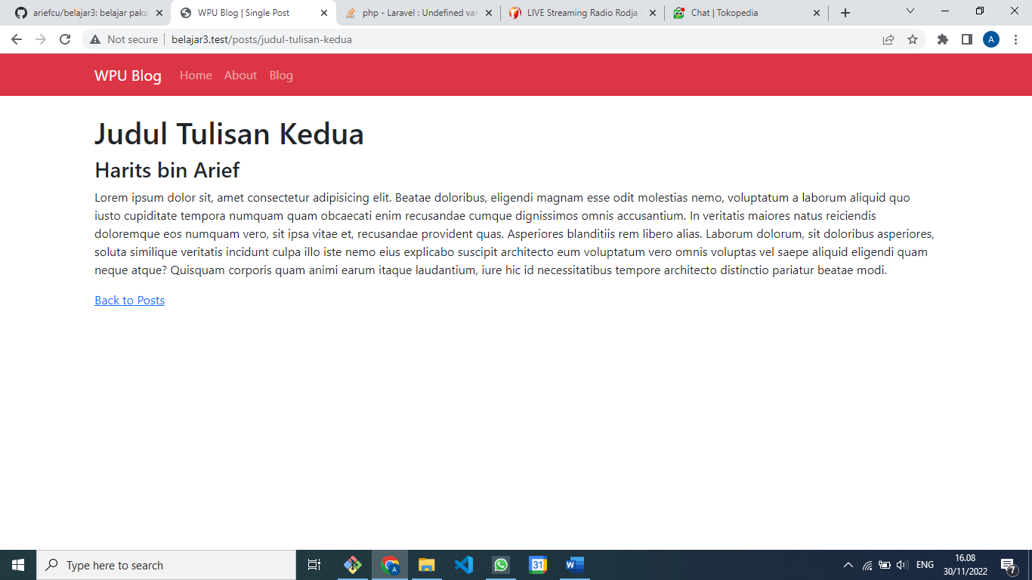

**web.php**

<?php

use App\Models\Post;

use Illuminate\Support\Facades\Route;

use App\Http\Controllers\PostController;

*/\**

*|--------------------------------------------------------------------------*

*| Web Routes*

*|--------------------------------------------------------------------------*

*|*

*| Here is where you can register web routes for your application. These*

*| routes are loaded by the RouteServiceProvider within a group which*

*| contains the "web" middleware group. Now create something great!*

*|*

*\*/*

*// Route::get('/', function () {*

*//    return view('welcome');*

*// });*

Route::get('/', function () {

    return view('home', [

        "title" => "Home"

    ]);

});

Route::get('/about', function () {

    return view('about', [

        "title" => "About",

        "name" => "Arief Cahyo Utomo",

        "email" => "ariefcu@gmail.com",

        "image" => "img/brain.png"

    ]);

});

Route::get('/posts', [PostController::class, 'index']);

Route::get('posts/{slug}', [postController::class, 'show']);

[**home.blade.php**](http://home.blade.php)

@extends('layouts.main')

@section('container')

    <h1>Halaman Home</h1>

@endsection

**about.blade.php**

<!DOCTYPE html>

<html lang="en">

@extends('layouts.main')

@section('container')

    <h1>Halaman About</h1>

    <h3>{{ $name }}</h3>

    <p>{{ $email }}</p>

    <img src={{ $image }} alt="$name" width="200" class="img-thumbnail rounded-circle">

@endsection

**posts.blade.php**

@extends('layouts.main')

@section('container')

    <h1>Halaman Blog Posts</h1>

    @foreach ($posts as $post)

        <article class="mb-5">

            <h2>

                <a href="/posts/{{ $post["slug"] }}">{{ $post["title"] }}</a>

            </h2>

            <h5>By: {{ $post["author"] }}</h5>

            <p>{{ $post["body"] }}</p>

        </article>

    @endforeach

@endsection

**post.blade.php**

@extends('layouts.main')

@section('container')

    <article>

        <h1>{{ $post["title"] }}</h1>

        <h3>{{ $post["author"] }}</h3>

        <p>{{ $post["body"] }}</p>

    </article>

    <a href="/posts">Back to Posts</a>

@endsection

**PostController.php**

<?php

namespace App\Http\Controllers;

use Illuminate\Http\Request;

use App\Models\Post;

class PostController extends Controller

{

    public function index()

    {

        return view('posts', [

            "title" => "Posts",

            "posts" => Post::all()

        ]);

    }

    public function show($slug)

    {

        return view('post', [

            "title" => "Single Post",

            "post" => Post::find($slug)

        ]);

    }

}

**Post.php**

<?php

namespace App\Models;

class Post

{

    private static $blog_posts = [

        [

            "title" => "Judul Tulisan Pertama",

            "slug"=> "judul-tulisan-pertama",

            "author" => "Arief Cahyo Utomo",

            "body" => "Lorem, ipsum dolor sit amet consectetur adipisicing elit. Asperiores molestias distinctio eos tempora enim sunt nesciunt commodi dolores, aut fuga et aliquam veniam rem quod velit, exercitationem quam beatae quis? Recusandae eveniet, dolorem aperiam porro voluptate veniam est pariatur? Temporibus architecto quae eius, nisi sequi debitis quia reiciendis culpa non iste voluptatum reprehenderit quasi beatae eum accusantium! Eum voluptates distinctio similique nobis molestias amet vel dolorem vero dicta quibusdam deleniti, molestiae libero quas expedita corporis, perspiciatis, animi quam at harum!"

        ],

        [

            "title" => "Judul Tulisan Kedua",

            "slug"=> "judul-tulisan-kedua",

            "author" => "Harits bin Arief",

            "body" => "Lorem ipsum dolor sit, amet consectetur adipisicing elit. Beatae doloribus, eligendi magnam esse odit molestias nemo, voluptatum a laborum aliquid quo iusto cupiditate tempora numquam quam obcaecati enim recusandae cumque dignissimos omnis accusantium. In veritatis maiores natus reiciendis doloremque eos numquam vero, sit ipsa vitae et, recusandae provident quas. Asperiores blanditiis rem libero alias. Laborum dolorum, sit doloribus asperiores, soluta similique veritatis incidunt culpa illo iste nemo eius explicabo suscipit architecto eum voluptatum vero omnis voluptas vel saepe aliquid eligendi quam neque atque? Quisquam corporis quam animi earum itaque laudantium, iure hic id necessitatibus tempore architecto distinctio pariatur beatae modi."

        ]

    ];

    public static function all()

    {

        return collect(self::$blog_posts);

    }

    public static function find($slug)

    {

        $posts = static::all();

        return $posts->firstWhere('slug', $slug);

    }

}

**main.blade.php**

<!doctype html>

<html lang="en">

  <head>

    <meta charset="utf-8">

    <meta name="viewport" content="width=device-width, initial-scale=1">

    <title>WPU Blog | {{ $title }}</title>

    <link href="https://cdn.jsdelivr.net/npm/bootstrap@5.2.3/dist/css/bootstrap.min.css" rel="stylesheet" integrity="sha384-rbsA2VBKQhggwzxH7pPCaAqO46MgnOM80zW1RWuH61DGLwZJEdK2Kadq2F9CUG65" crossorigin="anonymous">

  </head>

  <body>

@include('partials.navbar')

<div class="container mt-4">

    @yield('container')

</div>

    <script src="https://cdn.jsdelivr.net/npm/bootstrap@5.2.3/dist/js/bootstrap.bundle.min.js" integrity="sha384-kenU1KFdBIe4zVF0s0G1M5b4hcpxyD9F7jL+jjXkk+Q2h455rYXK/7HAuoJl+0I4" crossorigin="anonymous"></script>

  </body>

</html>

**navbar.blade.php**

<nav class="navbar navbar-expand-lg navbar-dark bg-danger">

    <div class="container">

      <a class="navbar-brand" href="/">WPU Blog</a>

      <button class="navbar-toggler" type="button" data-bs-toggle="collapse" data-bs-target="#navbarNav" aria-controls="navbarNav" aria-expanded="false" aria-label="Toggle navigation">

        <span class="navbar-toggler-icon"></span>

      </button>

      <div class="collapse navbar-collapse" id="navbarNav">

        <ul class="navbar-nav">

          <li class="nav-item">

            <a class="nav-link {{ ($title === "Home") ? 'active' : '' }}" href="/">Home</a>

          </li>

          <li class="nav-item">

            <a class="nav-link {{ ($title === "About") ? 'active' : '' }}" href="/about">About</a>

          </li>

          <li class="nav-item">

            <a class="nav-link {{ ($title === "Posts") ? 'active' : '' }}" href="/posts">Blog</a>

          </li>

        </ul>

      </div>

    </div>

  </nav>

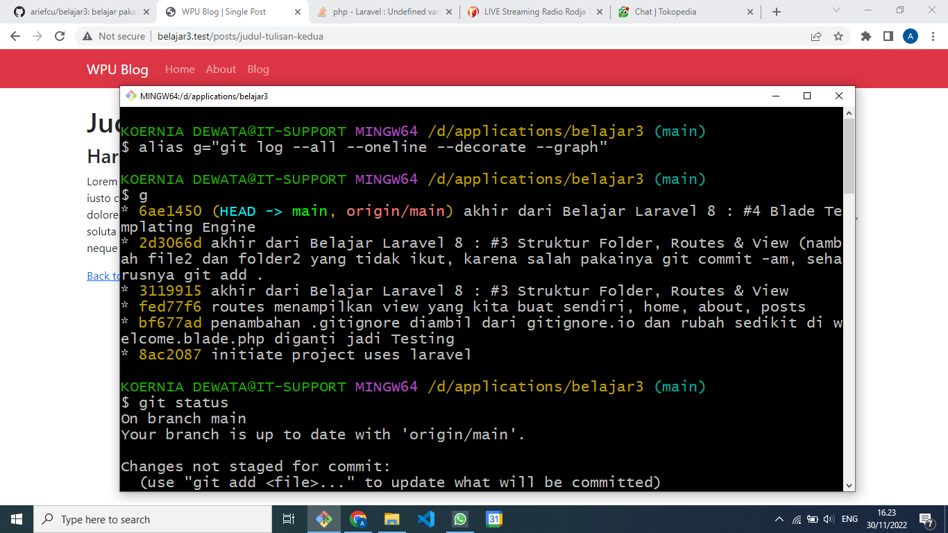

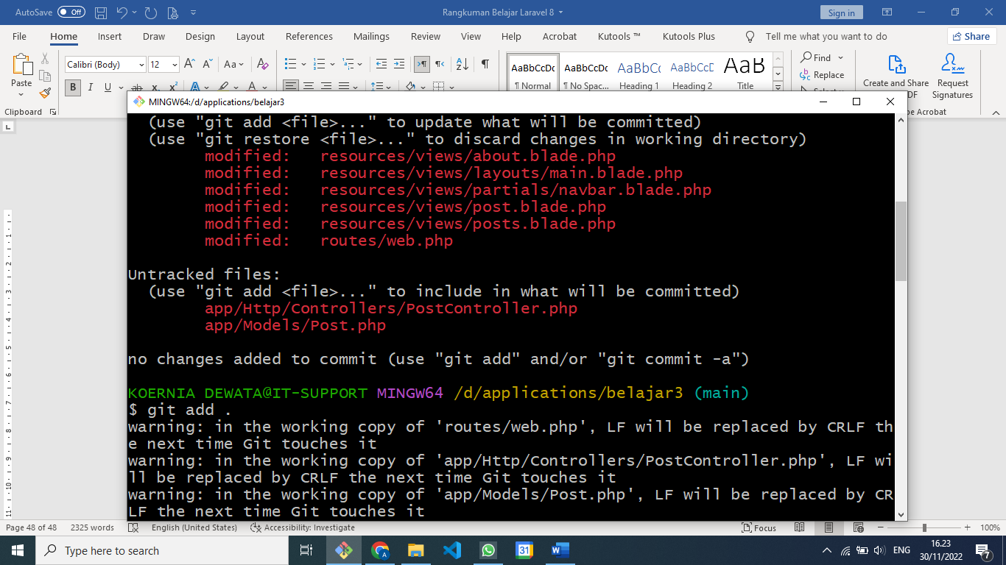

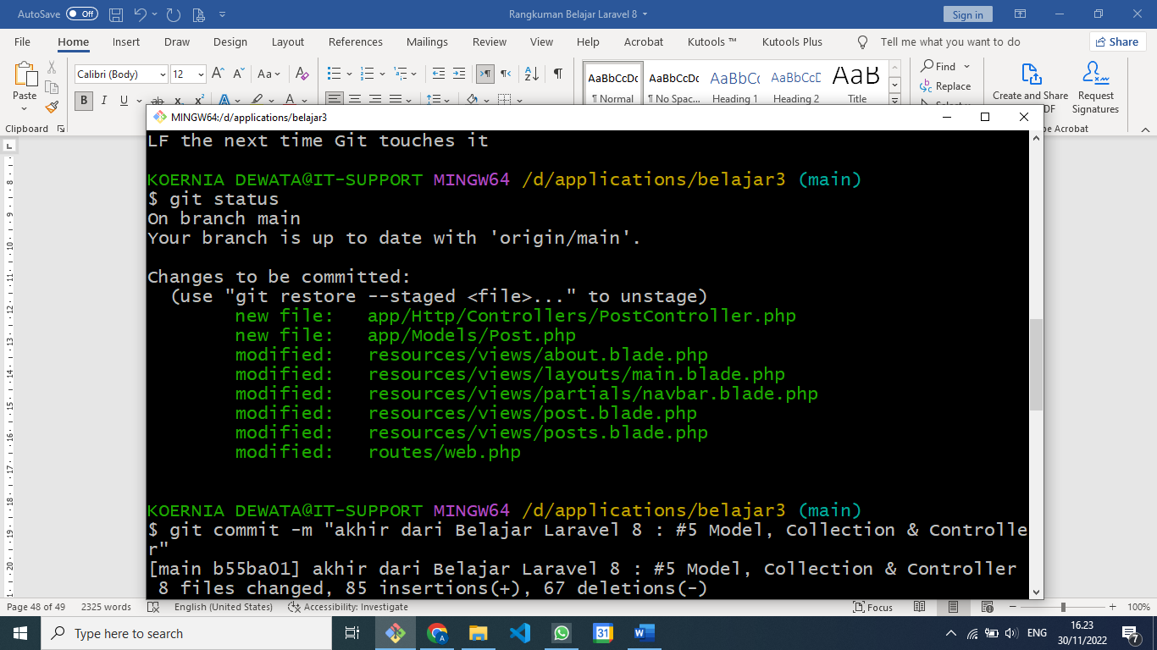

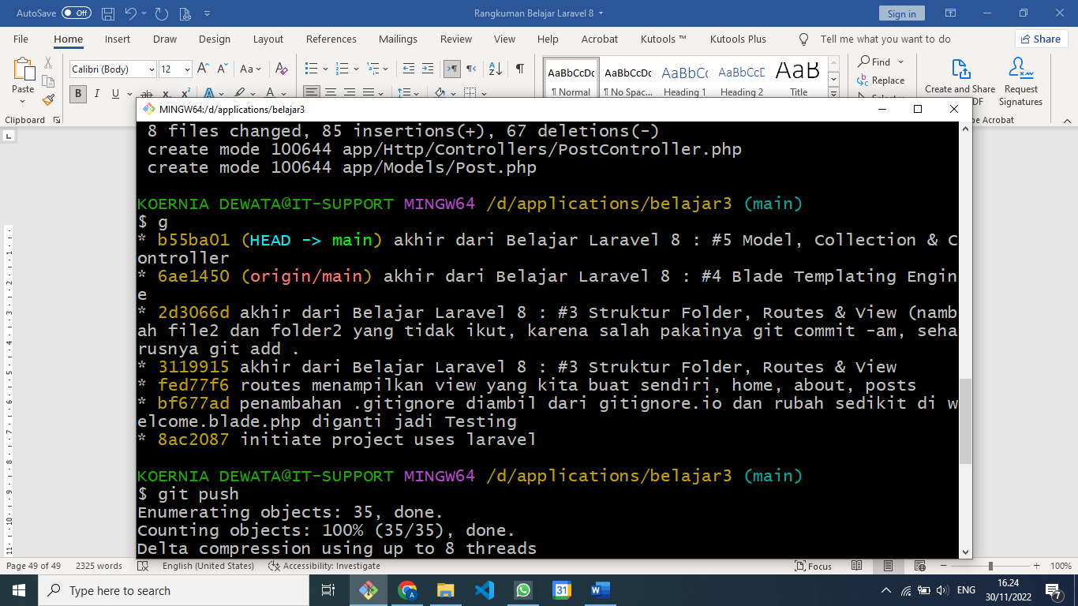

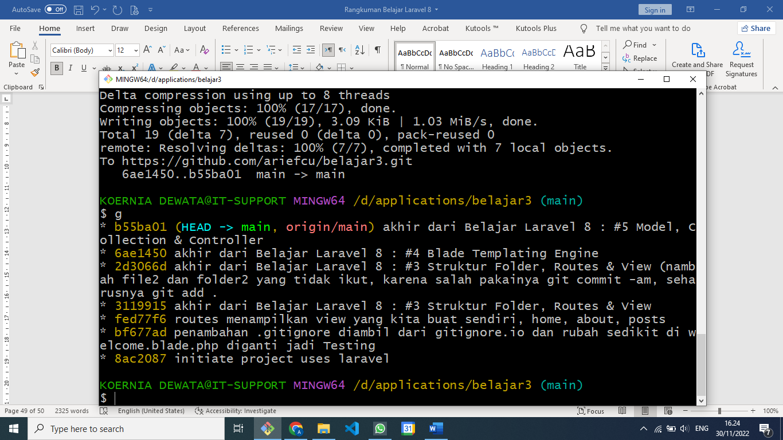

**Laravel 8 : #6 Database, Migration & Eloquent**

.env

APP_ENV=local (atau pilihan lainnya adalah dvelopment dan production)

APP_ENV=production

DB_DATABASE=wpu_blog

.env example

Sebagai acuan

.gitignore

Config/database.php

    'default' => env('DB_CONNECTION', 'mysql'),

Xamp Apache jalankan

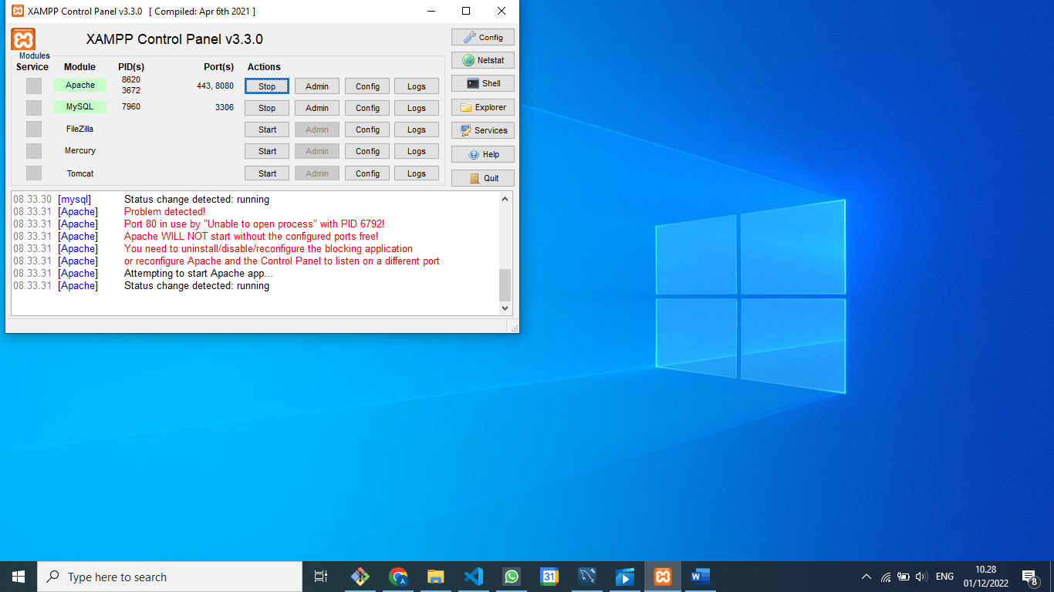

MySQL Workbench

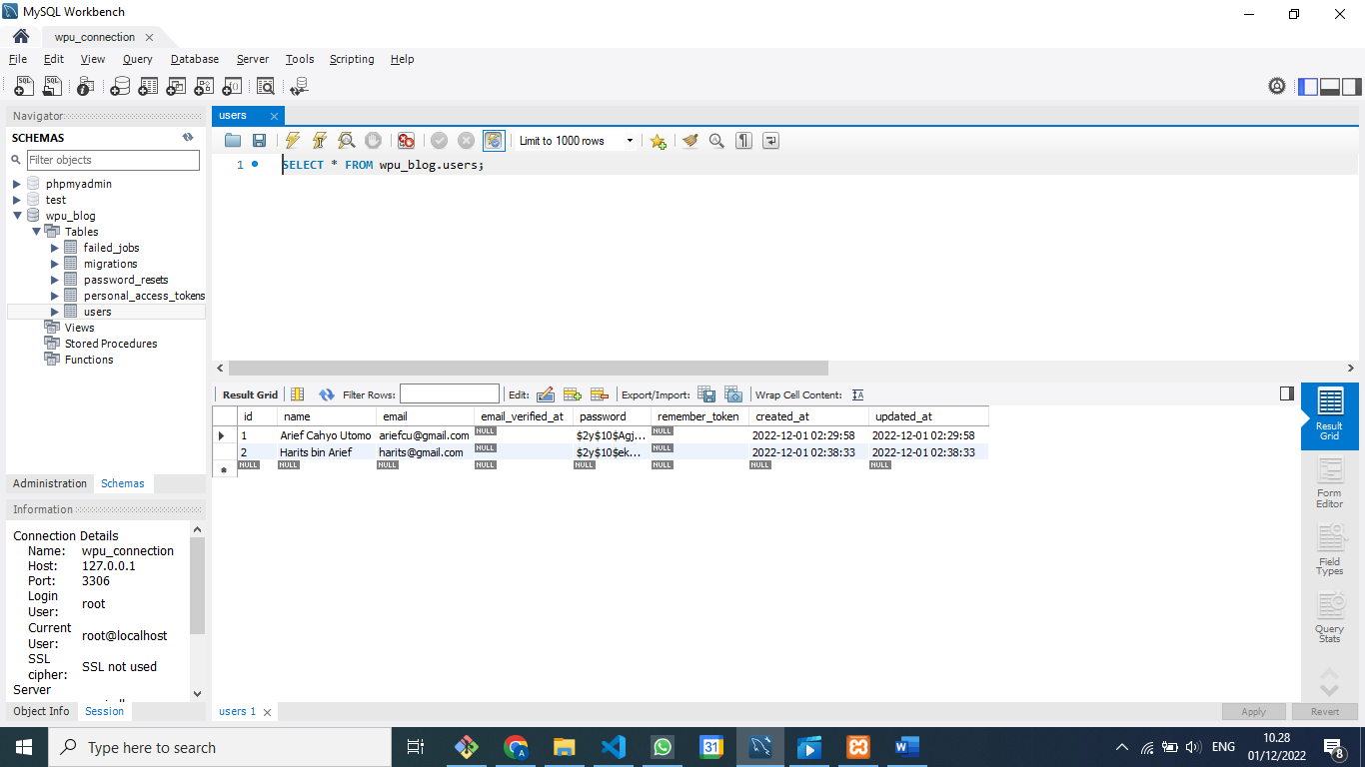

Create New Schema wpu_blog

Lalu di Git Bash ke folder d:\applications\belajar3

**artisan migrate**

Akan mengcreate table yang ada di table database/migrate

**php artisan migrate:rollback**

Sebaliknya untuk menghilangkan table yang sudah dibuat

**php artisan migrate:fresh**

Untuk melakukan menghilangkan table yang sudah ada lalu create table

App/Models/User.php berpasangan dengan database/migrations/create_user

Kalau APP_ENV=production

Ketika mau melakukan **php artisan migrate:fresh**

Akan ada konfirmasi dahulu, diingatkan kalau ini environment prroduction loh!!

**Eloquent**

**php artisan tinker**

untuk memasukkan data di tinker :

**$user = new App\Models\User;**

**App\Models\User {#3374}**

Atau

**$user = new User;**

**App\Models\User {#3375}**

$ php artisan tinker

Psy Shell v0.11.9 (PHP 8.1.10 — cli) by Justin Hileman

> $user = new App\Models\User;

= App\Models\User {#3680}

> $user = new User;

[!] Aliasing 'User' to 'App\Models\User' for this Tinker session.

= App\Models\User {#3681}

> $user->name = "Arief Cahyo Utomo";

= "Arief Cahyo Utomo"

> $user->email = "ariefcu@gmail.com"

= "ariefcu@gmail.com"

> $user->password = bcrypt('12345');

= "$2y$10$Agja90JCWpQd5/H8pOMJeOlXfGWZSVcrfEazytr2Z52hvoxkGWAoC"

> $user->save()

= true

Untuk melihat data

> $user->all()

= Illuminate\Database\Eloquent\Collection {#4378

all: [

App\Models\User {#4632

id: 1,

name: "Arief Cahyo Utomo",

email: "ariefcu@gmail.com",

email_verified_at: null,

#password: "$2y$10$Agja90JCWpQd5/H8pOMJeOlXfGWZSVcrfEazytr2Z52hvoxkGWAoC

",

#remember_token: null,

created_at: "2022-12-01 02:29:58",

updated_at: "2022-12-01 02:29:58",

},

],

}

Tambah satu data lagi

> $user = new User

[!] Aliasing 'User' to 'App\Models\User' for this Tinker session.

= App\Models\User {#3679}

> $user->name = 'Harits bin Arief'

= "Harits bin Arief"

> $user->email = 'harits@gmail.com'

= "harits@gmail.com"

> $user->password = bcrypt('12345')

= "$2y$10$ekOc279T0n9z58x5KGYY5O2wgI01W5PsriyZ9Ozd9wGFvNS46CIpa"

> $user->save()

= true

> $user->all()

= Illuminate\Database\Eloquent\Collection {#4017

all: [

App\Models\User {#4632

id: 1,

name: "Arief Cahyo Utomo",

email: "ariefcu@gmail.com",

email_verified_at: null,

#password: "$2y$10$Agja90JCWpQd5/H8pOMJeOlXfGWZSVcrfEazytr2Z52hvoxkGWAoC

",

#remember_token: null,

created_at: "2022-12-01 02:29:58",

updated_at: "2022-12-01 02:29:58",

},

App\Models\User {#4633

id: 2,

name: "Harits bin Arief",

email: "harits@gmail.com",

email_verified_at: null,

#password: "$2y$10$ekOc279T0n9z58x5KGYY5O2wgI01W5PsriyZ9Ozd9wGFvNS46CIpa

",

#remember_token: null,

created_at: "2022-12-01 02:38:33",

updated_at: "2022-12-01 02:38:33",

},

],

}

> $user->first()

= App\Models\User {#4376

id: 1,

name: "Arief Cahyo Utomo",

email: "ariefcu@gmail.com",

email_verified_at: null,

#password: "$2y$10$Agja90JCWpQd5/H8pOMJeOlXfGWZSVcrfEazytr2Z52hvoxkGWAoC",

#remember_token: null,

created_at: "2022-12-01 02:29:58",

updated_at: "2022-12-01 02:29:58",

}

> $user->find(2)

= App\Models\User {#4014

id: 2,

name: "Harits bin Arief",

email: "harits@gmail.com",

email_verified_at: null,

#password: "$2y$10$ekOc279T0n9z58x5KGYY5O2wgI01W5PsriyZ9Ozd9wGFvNS46CIpa",

#remember_token: null,

created_at: "2022-12-01 02:38:33",

updated_at: "2022-12-01 02:38:33",

}

> $user->find(2000)

= null

> $user->findOrFail(2000)

Illuminate\Database\Eloquent\ModelNotFoundException No query results for mod

el [App\Models\User] 2000.

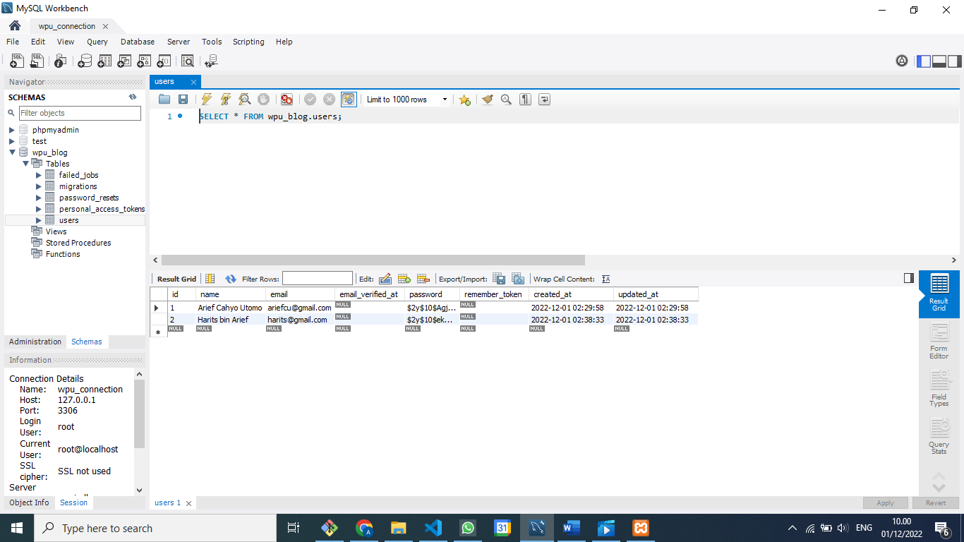

**Laravel 8 : #7 Post Model**

**Untuk make model dan create migrasi :**

KOERNIA DEWATA@IT-SUPPORT MINGW64 /d/applications/belajar3 (main)

**$ php artisan make:model -m Post**

INFO Model **[D:\applications\belajar3\app/Models/Post.php]** created successfully.

INFO Migration **[D:\applications\belajar3\database\migrations/2022_12_01_042001_create_posts_table.p**

**hp]** created successfully.

**Update file migrasinya :**

            $table->id();

            $table->string('title');

            $table->text('excerpt');

            $table->text('body');

            $table->timestamp('published_at');

            $table->timestamps();

**save**

**Untuk migrasi :**

KOERNIA DEWATA@IT-SUPPORT MINGW64 /d/applications/belajar3 (main)

**$ php artisan migrate:fresh**

Dropping all tables ..................................................................... 91ms DONE

INFO Preparing database.

Creating migration table ................................................................ 22ms DONE

INFO Running migrations.

2014_10_12_000000_create_users_table .................................................... 29ms DONE

2014_10_12_100000_create_password_resets_table .......................................... 29ms DONE

2019_08_19_000000_create_failed_jobs_table .............................................. 20ms DONE

2019_12_14_000001_create_personal_access_tokens_table ................................... 35ms DONE

2022_12_01_042001_create_posts_table .................................................... 17ms DONE

Isi data dengan :

php artisan tinker

KOERNIA DEWATA@IT-SUPPORT MINGW64 /d/applications/belajar3 (main)

$ php artisan tinker

Psy Shell v0.11.9 (PHP 8.1.10 — cli) by Justin Hileman

> $post = new Post

[!] Aliasing 'Post' to 'App\Models\Post' for this Tinker session.

= App\Models\Post {#3679}

> $post->title = "Judul Pertama"

= "Judul Pertama"

> $post->excerpt = "Lorem ipsum dolor sit, amet consectetur adipisicing elit. Alias, iusto amet pariatu

r, libero ipsum, maxime quae facere tenetur odit blanditiis veniam autem sequi. "

= "Lorem ipsum dolor sit, amet consectetur adipisicing elit. Alias, iusto amet pariatur, libero ipsum,

maxime quae facere tenetur odit blanditiis veniam autem sequi. "

> $post->body = "Lorem ipsum dolor sit, amet consectetur adipisicing elit. Alias, iusto amet pariatur,

libero ipsum, maxime quae facere tenetur odit blanditiis veniam autem sequi. Aliquid ullam, atque neces

sitatibus esse, fugit molestias impedit in suscipit voluptatibus rerum expedita ea maiores odit? Dolore

mque omnis a incidunt similique doloribus deleniti recusandae nisi molestiae reiciendis tempora dolor s

unt harum qui expedita ab sapiente, ullam, cupiditate beatae rem assumenda aliquid reprehenderit et ess

e. Iure eaque illum reprehenderit iste eos, est cum optio libero natus quos facere totam odit ex eius a

tque, eveniet porro vel aperiam nihil dolores voluptatibus! Molestiae, error. Exercitationem laborum to

tam nam quis a?"

= "Lorem ipsum dolor sit, amet consectetur adipisicing elit. Alias, iusto amet pariatur, libero ipsum,

maxime quae facere tenetur odit blanditiis veniam autem sequi. Aliquid ullam, atque necessitatibus esse

, fugit molestias impedit in suscipit voluptatibus rerum expedita ea maiores odit? Doloremque omnis a i

ncidunt similique doloribus deleniti recusandae nisi molestiae reiciendis tempora dolor sunt harum qui

expedita ab sapiente, ullam, cupiditate beatae rem assumenda aliquid reprehenderit et esse. Iure eaque

illum reprehenderit iste eos, est cum optio libero natus quos facere totam odit ex eius atque, eveniet

porro vel aperiam nihil dolores voluptatibus! Molestiae, error. Exercitationem laborum totam nam quis a

?"

Jangan lupa di save

> $post->save()

= true

Isi yang kedua tabelnya

> $post = new Post

= App\Models\Post {#4418}

> $post->title = "Judul Kedua"

= "Judul Kedua"

> $post->excerpt = "Lorem ipsum dolor sit, amet consectetur adipisicing elit. Alias, iusto amet pariatu

r, libero ipsum, maxime quae facere tenetur odit blanditiis veniam autem sequi. "

= "Lorem ipsum dolor sit, amet consectetur adipisicing elit. Alias, iusto amet pariatur, libero ipsum,

maxime quae facere tenetur odit blanditiis veniam autem sequi. "

> $post->body = "Lorem ipsum dolor sit, amet consectetur adipisicing elit. Alias, iusto amet pariatur,

libero ipsum, maxime quae facere tenetur odit blanditiis veniam autem sequi. Aliquid ullam, atque neces

sitatibus esse, fugit molestias impedit in suscipit voluptatibus rerum expedita ea maiores odit? Dolore

mque omnis a incidunt similique doloribus deleniti recusandae nisi molestiae reiciendis tempora dolor s

unt harum qui expedita ab sapiente, ullam, cupiditate beatae rem assumenda aliquid reprehenderit et ess

e. Iure eaque illum reprehenderit iste eos, est cum optio libero natus quos facere totam odit ex eius a

tque, eveniet porro vel aperiam nihil dolores voluptatibus! Molestiae, error. Exercitationem laborum to

tam nam quis a?"

= "Lorem ipsum dolor sit, amet consectetur adipisicing elit. Alias, iusto amet pariatur, libero ipsum,

maxime quae facere tenetur odit blanditiis veniam autem sequi. Aliquid ullam, atque necessitatibus esse

, fugit molestias impedit in suscipit voluptatibus rerum expedita ea maiores odit? Doloremque omnis a i

ncidunt similique doloribus deleniti recusandae nisi molestiae reiciendis tempora dolor sunt harum qui

expedita ab sapiente, ullam, cupiditate beatae rem assumenda aliquid reprehenderit et esse. Iure eaque

illum reprehenderit iste eos, est cum optio libero natus quos facere totam odit ex eius atque, eveniet

porro vel aperiam nihil dolores voluptatibus! Molestiae, error. Exercitationem laborum totam nam quis a

?"

> $post->save()

= true

> Post::all()

= Illuminate\Database\Eloquent\Collection {#4632

all: [

App\Models\Post {#4634

id: 1,

title: "Judul Pertama",

excerpt: "Lorem ipsum dolor sit, amet consectetur adipisicing elit. Alias, iusto amet pariatur,

libero ipsum, maxime quae facere tenetur odit blanditiis veniam autem sequi. ",

body: "Lorem ipsum dolor sit, amet consectetur adipisicing elit. Alias, iusto amet pariatur, li

bero ipsum, maxime quae facere tenetur odit blanditiis veniam autem sequi. Aliquid ullam, atque necessi

tatibus esse, fugit molestias impedit in suscipit voluptatibus rerum expedita ea maiores odit? Doloremq

ue omnis a incidunt similique doloribus deleniti recusandae nisi molestiae reiciendis tempora dolor sun

t harum qui expedita ab sapiente, ullam, cupiditate beatae rem assumenda aliquid reprehenderit et esse.

Iure eaque illum reprehenderit iste eos, est cum optio libero natus quos facere totam odit ex eius atq

ue, eveniet porro vel aperiam nihil dolores voluptatibus! Molestiae, error. Exercitationem laborum tota

m nam quis a?",

published_at: "2022-12-01 13:08:50",

created_at: "2022-12-01 06:08:50",

updated_at: "2022-12-01 06:08:50",

},

App\Models\Post {#4635

id: 2,

title: "Judul Kedua",

excerpt: "Lorem ipsum dolor sit, amet consectetur adipisicing elit. Alias, iusto amet pariatur,

libero ipsum, maxime quae facere tenetur odit blanditiis veniam autem sequi. ",

body: "Lorem ipsum dolor sit, amet consectetur adipisicing elit. Alias, iusto amet pariatur, li

bero ipsum, maxime quae facere tenetur odit blanditiis veniam autem sequi. Aliquid ullam, atque necessi

tatibus esse, fugit molestias impedit in suscipit voluptatibus rerum expedita ea maiores odit? Doloremq

ue omnis a incidunt similique doloribus deleniti recusandae nisi molestiae reiciendis tempora dolor sun

t harum qui expedita ab sapiente, ullam, cupiditate beatae rem assumenda aliquid reprehenderit et esse.

Iure eaque illum reprehenderit iste eos, est cum optio libero natus quos facere totam odit ex eius atq

ue, eveniet porro vel aperiam nihil dolores voluptatibus! Molestiae, error. Exercitationem laborum tota

m nam quis a?",

published_at: "2022-12-01 13:11:17",

created_at: "2022-12-01 06:11:17",

updated_at: "2022-12-01 06:11:17",

},

],

}

> Post::first()

= App\Models\Post {#4641

id: 1,

title: "Judul Pertama",

excerpt: "Lorem ipsum dolor sit, amet consecte

tur adipisicing elit. Alias, iusto amet pariatur,

libero ipsum, maxime quae facere tenetur odit blan

ditiis veniam autem sequi. ",

body: "Lorem ipsum dolor sit, amet consectetur

adipisicing elit. Alias, iusto amet pariatur, libero ipsum, maxime quae facere tenetur odit blanditiis

veniam autem sequi. Aliquid ullam, atque necessitatibus esse, fugit molestias impedit in suscipit volu

ptatibus rerum expedita ea maiores odit? Doloremque omnis a incidunt similique doloribus deleniti recus

andae nisi molestiae reiciendis tempora dolor sunt harum qui expedita ab sapiente, ullam, cupiditate be

atae rem assumenda aliquid reprehenderit et esse. Iure eaque illum reprehenderit iste eos, est cum opti

o libero natus quos facere totam odit ex eius atque, eveniet porro vel aperiam nihil dolores voluptatib

us! Molestiae, error. Exercitationem laborum totam nam quis a?",

published_at: "2022-12-01 13:08:50",

created_at: "2022-12-01 06:08:50",

updated_at: "2022-12-01 06:08:50",

}

> Post::pluck("title")

= Illuminate\Support\Collection {#4637

all: [

"Judul Pertama",

"Judul Kedua",

],

}

> Post::find(2)

= App\Models\Post {#3690

id: 2,

title: "Judul Kedua",

excerpt: "Lorem ipsum dolor sit, amet consectetur adipisicing elit. Alias, iusto amet pariatur, lib

ero ipsum, maxime quae facere tenetur odit blanditiis veniam autem sequi. ",

body: "Lorem ipsum dolor sit, amet consectetur adipisicing elit. Alias, iusto amet pariatur, libero

ipsum, maxime quae facere tenetur odit blanditiis veniam autem sequi. Aliquid ullam, atque necessitati

bus esse, fugit molestias impedit in suscipit voluptatibus rerum expedita ea maiores odit? Doloremque o

mnis a incidunt similique doloribus deleniti recusandae nisi molestiae reiciendis tempora dolor sunt ha

rum qui expedita ab sapiente, ullam, cupiditate beatae rem assumenda aliquid reprehenderit et esse. Iur

e eaque illum reprehenderit iste eos, est cum optio libero natus quos facere totam odit ex eius atque,

eveniet porro vel aperiam nihil dolores voluptatibus! Molestiae, error. Exercitationem laborum totam na

m quis a?",

published_at: "2022-12-01 13:11:17",

created_at: "2022-12-01 06:11:17",

updated_at: "2022-12-01 06:11:17",

}

Coba ada pragraf 2

> $post = new Post

= App\Models\Post {#4420}

> $post->title = "Judul Ketiga"

= "Judul Ketiga"

> $post->excerpt = "Lorem ipsum dolor sit, amet consectetur adipisicing elit. Alias, iusto amet pariatu

r, libero ipsum, maxime quae facere tenetur odit blanditiis veniam autem sequi. "

= "Lorem ipsum dolor sit, amet consectetur adipisicing elit. Alias, iusto amet pariatur, libero ipsum,

maxime quae facere tenetur odit blanditiis veniam autem sequi. "

> $post->body = "<p>Lorem ipsum dolor sit amet, consectetur adipisicing elit. Magni cupiditate nemo cor

poris at delectus illum commodi harum dicta fugiat nam facilis quibusdam atque reiciendis alias quae, q

uis nihil culpa praesentium ullam velit, iure pariatur explicabo ea. Nesciunt dolorem voluptatibus adip

isci eius quasi autem molestiae doloremque ad, eveniet tempore illum ab sint sed veniam natus facilis o

dit iste impedit accusantium laudantium perferendis? </p><p>Qui doloribus vel accusamus veritatis aut c

onsequatur, quis fugit praesentium, eos facere iure quibusdam aliquid? Velit, quasi. Obcaecati minus ni

si ipsam ducimus voluptatibus ullam, mollitia necessitatibus autem non voluptas! Consequatur ad, obcaec

ati quae numquam quibusdam quis repudiandae adipisci. Facere officia amet deserunt vel perferendis nece

ssitatibus quod optio voluptate nulla quasi! Vitae ducimus eveniet error! Fugiat nihil consectetur aut

unde?</p>"

= "<p>Lorem ipsum dolor sit amet, consectetur adipisicing elit. Magni cupiditate nemo corporis at delec

tus illum commodi harum dicta fugiat nam facilis quibusdam atque reiciendis alias quae, quis nihil culp

a praesentium ullam velit, iure pariatur explicabo ea. Nesciunt dolorem voluptatibus adipisci eius quas

i autem molestiae doloremque ad, eveniet tempore illum ab sint sed veniam natus facilis odit iste imped

it accusantium laudantium perferendis? </p><p>Qui doloribus vel accusamus veritatis aut consequatur, qu

is fugit praesentium, eos facere iure quibusdam aliquid? Velit, quasi. Obcaecati minus nisi ipsam ducim

us voluptatibus ullam, mollitia necessitatibus autem non voluptas! Consequatur ad, obcaecati quae numqu

am quibusdam quis repudiandae adipisci. Facere officia amet deserunt vel perferendis necessitatibus quo

d optio voluptate nulla quasi! Vitae ducimus eveniet error! Fugiat nihil consectetur aut unde?</p>"

> $post->save()

= true

Post::create([

    "title" => "Judul Keempat",

    "excerpt" => "Lorem ipsum dolor sit, amet consectetur adipisicing elit. Amet aspernatur ipsam, doloremque voluptatem quis incidunt quasi deleniti officiis cupiditate eligendi similique quos fuga sint error, accusantium suscipit aliquam.",

    "body" => "<p>Lorem ipsum dolor sit, amet consectetur adipisicing elit. Amet aspernatur ipsam, doloremque voluptatem quis incidunt quasi deleniti officiis cupiditate eligendi similique quos fuga sint error, accusantium suscipit aliquam. Dignissimos corporis, dolore ea modi ex, voluptatibus soluta eum natus, accusantium at id voluptas aperiam maxime assumenda rem. Nesciunt repellendus itaque corrupti natus sapiente alias fuga facilis consectetur eum. Est, sequi obcaecati. </p><p>Velit provident rem perspiciatis enim quibusdam hic vero placeat eum, molestias, consequatur quia atque soluta sint labore doloremque aut? Cum dolore labore ipsa commodi odio explicabo dolor quisquam aliquam esse? </p><p>Sit et id eveniet, officiis aperiam fuga suscipit rerum minus, maxime illum corrupti non ullam enim consectetur totam accusamus maiores sunt! Repellat aspernatur voluptatem dicta. Esse minus quo ad fugiat corrupti, perspiciatis eaque quasi sint dolore maiores fugit sequi facere dolorem animi laborum voluptatibus numquam quisquam dolorum temporibus officia nulla nihil est nisi architecto? Ea enim corporis ut facere porro.</p>"

])

Post.php

<?php

namespace App\Models;

use Illuminate\Database\Eloquent\Factories\HasFactory;

use Illuminate\Database\Eloquent\Model;

class Post extends Model

{

    use HasFactory;

    protected $fillable = ['title', 'excerpt', 'body'];

}

Hasilnya seperti berikut :

> Post::create([

. "title" => "Judul Keempat",

. "excerpt" => "Lorem ipsum dolor sit, amet consectetur adipisicing elit. Amet aspernatur ipsam, do

loremque voluptatem quis incidunt quasi deleniti officiis cupiditate eligendi similique quos fuga sint

error, accusantium suscipit aliquam.",

. "body" => "<p>Lorem ipsum dolor sit, amet consectetur adipisicing elit. Amet aspernatur ipsam, do

loremque voluptatem quis incidunt quasi deleniti officiis cupiditate eligendi similique quos fuga sint

error, accusantium suscipit aliquam. Dignissimos corporis, dolore ea modi ex, voluptatibus soluta eum n

atus, accusantium at id voluptas aperiam maxime assumenda rem. Nesciunt repellendus itaque corrupti nat

us sapiente alias fuga facilis consectetur eum. Est, sequi obcaecati. </p><p>Velit provident rem perspi

ciatis enim quibusdam hic vero placeat eum, molestias, consequatur quia atque soluta sint labore dolore

mque aut? Cum dolore labore ipsa commodi odio explicabo dolor quisquam aliquam esse? </p><p>Sit et id e

veniet, officiis aperiam fuga suscipit rerum minus, maxime illum corrupti non ullam enim consectetur to

tam accusamus maiores sunt! Repellat aspernatur voluptatem dicta. Esse minus quo ad fugiat corrupti, pe

rspiciatis eaque quasi sint dolore maiores fugit sequi facere dolorem animi laborum voluptatibus numqua

m quisquam dolorum temporibus officia nulla nihil est nisi architecto? Ea enim corporis ut facere porro

.</p>"

. ])

[!] Aliasing 'Post' to 'App\Models\Post' for this Tinker session.

= App\Models\Post {#3684

title: "Judul Keempat",

excerpt: "Lorem ipsum dolor sit, amet consectetur adipisicing elit. Amet aspernatur ipsam, doloremq

ue voluptatem quis incidunt quasi deleniti officiis cupiditate eligendi similique quos fuga sint error,

accusantium suscipit aliquam.",

body: "<p>Lorem ipsum dolor sit, amet consectetur adipisicing elit. Amet aspernatur ipsam, doloremq

ue voluptatem quis incidunt quasi deleniti officiis cupiditate eligendi similique quos fuga sint error,

accusantium suscipit aliquam. Dignissimos corporis, dolore ea modi ex, voluptatibus soluta eum natus,

accusantium at id voluptas aperiam maxime assumenda rem. Nesciunt repellendus itaque corrupti natus sap

iente alias fuga facilis consectetur eum. Est, sequi obcaecati. </p><p>Velit provident rem perspiciatis

enim quibusdam hic vero placeat eum, molestias, consequatur quia atque soluta sint labore doloremque a

ut? Cum dolore labore ipsa commodi odio explicabo dolor quisquam aliquam esse? </p><p>Sit et id eveniet

, officiis aperiam fuga suscipit rerum minus, maxime illum corrupti non ullam enim consectetur totam ac

cusamus maiores sunt! Repellat aspernatur voluptatem dicta. Esse minus quo ad fugiat corrupti, perspici

atis eaque quasi sint dolore maiores fugit sequi facere dolorem animi laborum voluptatibus numquam quis

quam dolorum temporibus officia nulla nihil est nisi architecto? Ea enim corporis ut facere porro.</p>"

,

updated_at: "2022-12-01 07:17:47",

created_at: "2022-12-01 07:17:47",

id: 4,

}

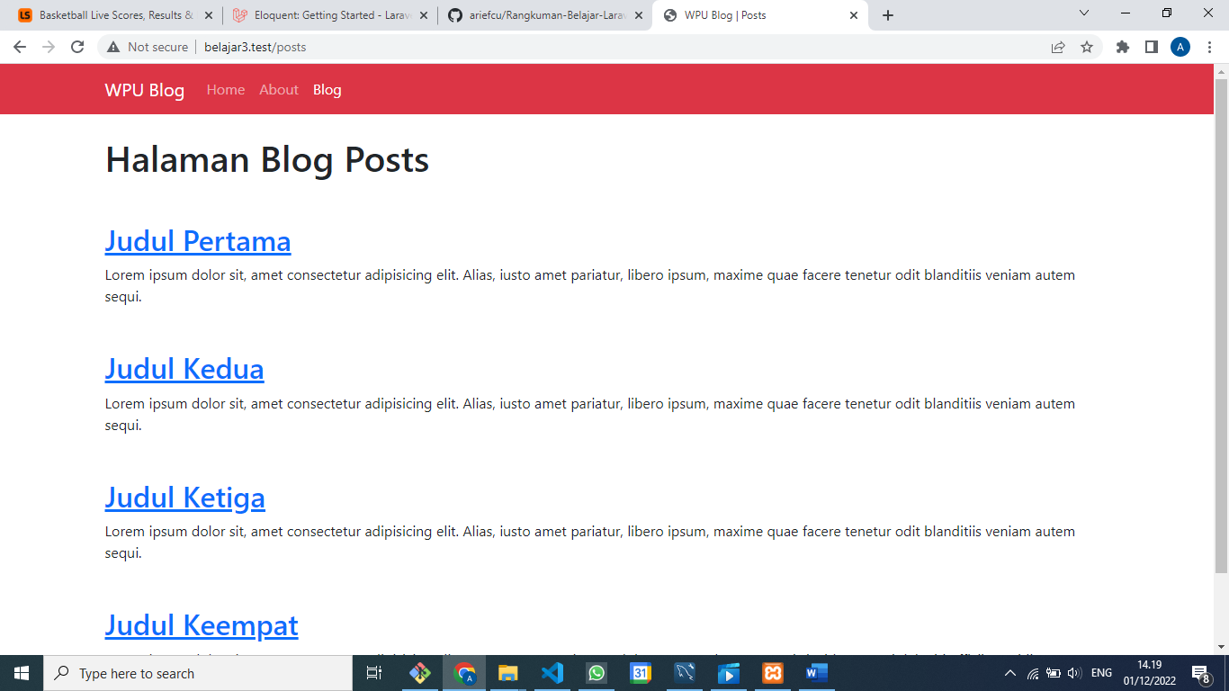

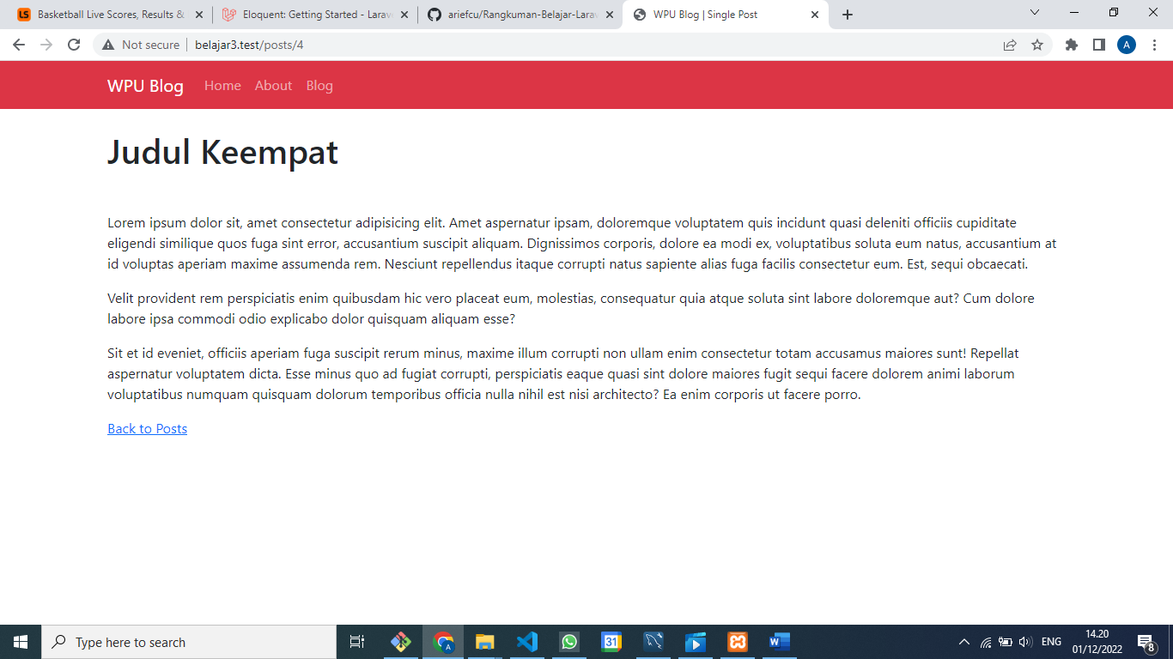

Post.php

<?php

namespace App\Models;

use Illuminate\Database\Eloquent\Factories\HasFactory;

use Illuminate\Database\Eloquent\Model;

class Post extends Model

{

    use HasFactory;

*// protected $fillable = ['title', 'excerpt', 'body'];*

    protected $guarded = ['id']

}

Post::create([

    "title" => "Judul Kelima",

    "excerpt" => "Lorem ipsum dolor sit, amet consectetur adipisicing elit. Amet aspernatur ipsam, doloremque voluptatem quis incidunt quasi deleniti officiis cupiditate eligendi similique quos fuga sint error, accusantium suscipit aliquam.",

    "body" => "<p>Lorem ipsum dolor sit, amet consectetur adipisicing elit. Amet aspernatur ipsam, doloremque voluptatem quis incidunt quasi deleniti officiis cupiditate eligendi similique quos fuga sint error, accusantium suscipit aliquam. Dignissimos corporis, dolore ea modi ex, voluptatibus soluta eum natus, accusantium at id voluptas aperiam maxime assumenda rem. Nesciunt repellendus itaque corrupti natus sapiente alias fuga facilis consectetur eum. Est, sequi obcaecati. </p><p>Velit provident rem perspiciatis enim quibusdam hic vero placeat eum, molestias, consequatur quia atque soluta sint labore doloremque aut? Cum dolore labore ipsa commodi odio explicabo dolor quisquam aliquam esse? </p><p>Sit et id eveniet, officiis aperiam fuga suscipit rerum minus, maxime illum corrupti non ullam enim consectetur totam accusamus maiores sunt! Repellat aspernatur voluptatem dicta. Esse minus quo ad fugiat corrupti, perspiciatis eaque quasi sint dolore maiores fugit sequi facere dolorem animi laborum voluptatibus numquam quisquam dolorum temporibus officia nulla nihil est nisi architecto? Ea enim corporis ut facere porro.</p>"

])

KOERNIA DEWATA@IT-SUPPORT MINGW64 /d/applications/belajar3 (main)

$ php artisan tinker

Psy Shell v0.11.9 (PHP 8.1.10 — cli) by Justin Hileman

> Post::create([

. "title" => "Judul Kelima",

. "excerpt" => "Lorem ipsum dolor sit, amet consectetur adipisicing elit. Amet aspernatur ipsam, do

loremque voluptatem quis incidunt quasi deleniti officiis cupiditate eligendi similique quos fuga sint

error, accusantium suscipit aliquam.",

. "body" => "<p>Lorem ipsum dolor sit, amet consectetur adipisicing elit. Amet aspernatur ipsam, do

loremque voluptatem quis incidunt quasi deleniti officiis cupiditate eligendi similique quos fuga sint

error, accusantium suscipit aliquam. Dignissimos corporis, dolore ea modi ex, voluptatibus soluta eum n

atus, accusantium at id voluptas aperiam maxime assumenda rem. Nesciunt repellendus itaque corrupti nat

us sapiente alias fuga facilis consectetur eum. Est, sequi obcaecati. </p><p>Velit provident rem perspi

ciatis enim quibusdam hic vero placeat eum, molestias, consequatur quia atque soluta sint labore dolore

mque aut? Cum dolore labore ipsa commodi odio explicabo dolor quisquam aliquam esse? </p><p>Sit et id e

veniet, officiis aperiam fuga suscipit rerum minus, maxime illum corrupti non ullam enim consectetur to

tam accusamus maiores sunt! Repellat aspernatur voluptatem dicta. Esse minus quo ad fugiat corrupti, pe

rspiciatis eaque quasi sint dolore maiores fugit sequi facere dolorem animi laborum voluptatibus numqua

m quisquam dolorum temporibus officia nulla nihil est nisi architecto? Ea enim corporis ut facere porro

.</p>"

. ])

[!] Aliasing 'Post' to 'App\Models\Post' for this Tinker session.

= App\Models\Post {#3684

title: "Judul Kelima",

excerpt: "Lorem ipsum dolor sit, amet consectetur adipisicing elit. Amet aspernatur ipsam, doloremq

ue voluptatem quis incidunt quasi deleniti officiis cupiditate eligendi similique quos fuga sint error,

accusantium suscipit aliquam.",

body: "<p>Lorem ipsum dolor sit, amet consectetur adipisicing elit. Amet aspernatur ipsam, doloremq

ue voluptatem quis incidunt quasi deleniti officiis cupiditate eligendi similique quos fuga sint error,

accusantium suscipit aliquam. Dignissimos corporis, dolore ea modi ex, voluptatibus soluta eum natus,

accusantium at id voluptas aperiam maxime assumenda rem. Nesciunt repellendus itaque corrupti natus sap

iente alias fuga facilis consectetur eum. Est, sequi obcaecati. </p><p>Velit provident rem perspiciatis

enim quibusdam hic vero placeat eum, molestias, consequatur quia atque soluta sint labore doloremque a

ut? Cum dolore labore ipsa commodi odio explicabo dolor quisquam aliquam esse? </p><p>Sit et id eveniet

, officiis aperiam fuga suscipit rerum minus, maxime illum corrupti non ullam enim consectetur totam ac

cusamus maiores sunt! Repellat aspernatur voluptatem dicta. Esse minus quo ad fugiat corrupti, perspici

atis eaque quasi sint dolore maiores fugit sequi facere dolorem animi laborum voluptatibus numquam quis

quam dolorum temporibus officia nulla nihil est nisi architecto? Ea enim corporis ut facere porro.</p>"

,

updated_at: "2022-12-01 07:32:10",

created_at: "2022-12-01 07:32:10",

id: 5,

}

> Post::find(3)->update(['title'=>'Judul Ketiga Dirubah'])

= true

> Post::all()

= Illuminate\Database\Eloquent\Collection {#4629

all: [

App\Models\Post {#4641

id: 1,

title: "Judul Pertama",

excerpt: "Lorem ipsum dolor sit, amet consectetur adipisicing elit. Alias, iusto amet pariatur,

libero ipsum, maxime quae facere tenetur odit blanditiis veniam autem sequi. ",

body: "Lorem ipsum dolor sit, amet consectetur adipisicing elit. Alias, iusto amet pariatur, li

bero ipsum, maxime quae facere tenetur odit blanditiis veniam autem sequi. Aliquid ullam, atque necessi

tatibus esse, fugit molestias impedit in suscipit voluptatibus rerum expedita ea maiores odit? Doloremq

ue omnis a incidunt similique doloribus deleniti recusandae nisi molestiae reiciendis tempora dolor sun

t harum qui expedita ab sapiente, ullam, cupiditate beatae rem assumenda aliquid reprehenderit et esse.

Iure eaque illum reprehenderit iste eos, est cum optio libero natus quos facere totam odit ex eius atq

ue, eveniet porro vel aperiam nihil dolores voluptatibus! Molestiae, error. Exercitationem laborum tota

m nam quis a?",

published_at: "2022-12-01 13:08:50",

created_at: "2022-12-01 06:08:50",

updated_at: "2022-12-01 06:08:50",

},

App\Models\Post {#4642

id: 2,

title: "Judul Kedua",

excerpt: "Lorem ipsum dolor sit, amet consectetur adipisicing elit. Alias, iusto amet pariatur,

libero ipsum, maxime quae facere tenetur odit blanditiis veniam autem sequi. ",

body: "Lorem ipsum dolor sit, amet consectetur adipisicing elit. Alias, iusto amet pariatur, li

bero ipsum, maxime quae facere tenetur odit blanditiis veniam autem sequi. Aliquid ullam, atque necessi

tatibus esse, fugit molestias impedit in suscipit voluptatibus rerum expedita ea maiores odit? Doloremq

ue omnis a incidunt similique doloribus deleniti recusandae nisi molestiae reiciendis tempora dolor sun

t harum qui expedita ab sapiente, ullam, cupiditate beatae rem assumenda aliquid reprehenderit et esse.

Iure eaque illum reprehenderit iste eos, est cum optio libero natus quos facere totam odit ex eius atq

ue, eveniet porro vel aperiam nihil dolores voluptatibus! Molestiae, error. Exercitationem laborum tota

m nam quis a?",

published_at: "2022-12-01 13:11:17",

created_at: "2022-12-01 06:11:17",

updated_at: "2022-12-01 06:11:17",

},

App\Models\Post {#4643

id: 3,

title: "Judul Ketiga Dirubah",

excerpt: "Lorem ipsum dolor sit, amet consectetur adipisicing elit. Alias, iusto amet pariatur,

libero ipsum, maxime quae facere tenetur odit blanditiis veniam autem sequi. ",

body: "<p>Lorem ipsum dolor sit amet, consectetur adipisicing elit. Magni cupiditate nemo corpo

ris at delectus illum commodi harum dicta fugiat nam facilis quibusdam atque reiciendis alias quae, qui

s nihil culpa praesentium ullam velit, iure pariatur explicabo ea. Nesciunt dolorem voluptatibus adipis

ci eius quasi autem molestiae doloremque ad, eveniet tempore illum ab sint sed veniam natus facilis odi

t iste impedit accusantium laudantium perferendis? </p><p>Qui doloribus vel accusamus veritatis aut con

sequatur, quis fugit praesentium, eos facere iure quibusdam aliquid? Velit, quasi. Obcaecati minus nisi

ipsam ducimus voluptatibus ullam, mollitia necessitatibus autem non voluptas! Consequatur ad, obcaecat

i quae numquam quibusdam quis repudiandae adipisci. Facere officia amet deserunt vel perferendis necess

itatibus quod optio voluptate nulla quasi! Vitae ducimus eveniet error! Fugiat nihil consectetur aut un

de?</p>",

published_at: "2022-12-01 14:36:12",

created_at: "2022-12-01 06:39:03",

updated_at: "2022-12-01 07:36:12",

},

App\Models\Post {#4644

id: 4,

title: "Judul Keempat",

excerpt: "Lorem ipsum dolor sit, amet consectetur adipisicing elit. Amet aspernatur ipsam, dolo

remque voluptatem quis incidunt quasi deleniti officiis cupiditate eligendi similique quos fuga sint er

ror, accusantium suscipit aliquam.",

body: "<p>Lorem ipsum dolor sit, amet consectetur adipisicing elit. Amet aspernatur ipsam, dolo

remque voluptatem quis incidunt quasi deleniti officiis cupiditate eligendi similique quos fuga sint er

ror, accusantium suscipit aliquam. Dignissimos corporis, dolore ea modi ex, voluptatibus soluta eum nat

us, accusantium at id voluptas aperiam maxime assumenda rem. Nesciunt repellendus itaque corrupti natus

sapiente alias fuga facilis consectetur eum. Est, sequi obcaecati. </p><p>Velit provident rem perspici

atis enim quibusdam hic vero placeat eum, molestias, consequatur quia atque soluta sint labore doloremq

ue aut? Cum dolore labore ipsa commodi odio explicabo dolor quisquam aliquam esse? </p><p>Sit et id eve

niet, officiis aperiam fuga suscipit rerum minus, maxime illum corrupti non ullam enim consectetur tota

m accusamus maiores sunt! Repellat aspernatur voluptatem dicta. Esse minus quo ad fugiat corrupti, pers

piciatis eaque quasi sint dolore maiores fugit sequi facere dolorem animi laborum voluptatibus numquam

quisquam dolorum temporibus officia nulla nihil est nisi architecto? Ea enim corporis ut facere porro.<

/p>",

published_at: "2022-12-01 14:17:47",

created_at: "2022-12-01 07:17:47",

updated_at: "2022-12-01 07:17:47",

},

App\Models\Post {#4645

id: 5,

title: "Judul Kelima",

excerpt: "Lorem ipsum dolor sit, amet consectetur adipisicing elit. Amet aspernatur ipsam, dolo

remque voluptatem quis incidunt quasi deleniti officiis cupiditate eligendi similique quos fuga sint er

ror, accusantium suscipit aliquam.",

body: "<p>Lorem ipsum dolor sit, amet consectetur adipisicing elit. Amet aspernatur ipsam, dolo

remque voluptatem quis incidunt quasi deleniti officiis cupiditate eligendi similique quos fuga sint er

ror, accusantium suscipit aliquam. Dignissimos corporis, dolore ea modi ex, voluptatibus soluta eum nat

us, accusantium at id voluptas aperiam maxime assumenda rem. Nesciunt repellendus itaque corrupti natus

sapiente alias fuga facilis consectetur eum. Est, sequi obcaecati. </p><p>Velit provident rem perspici

atis enim quibusdam hic vero placeat eum, molestias, consequatur quia atque soluta sint labore doloremq

ue aut? Cum dolore labore ipsa commodi odio explicabo dolor quisquam aliquam esse? </p><p>Sit et id eve

niet, officiis aperiam fuga suscipit rerum minus, maxime illum corrupti non ullam enim consectetur tota

m accusamus maiores sunt! Repellat aspernatur voluptatem dicta. Esse minus quo ad fugiat corrupti, pers

piciatis eaque quasi sint dolore maiores fugit sequi facere dolorem animi laborum voluptatibus numquam

quisquam dolorum temporibus officia nulla nihil est nisi architecto? Ea enim corporis ut facere porro.<

/p>",

published_at: "2022-12-01 14:32:10",

created_at: "2022-12-01 07:32:10",

updated_at: "2022-12-01 07:32:10",

},

],

}

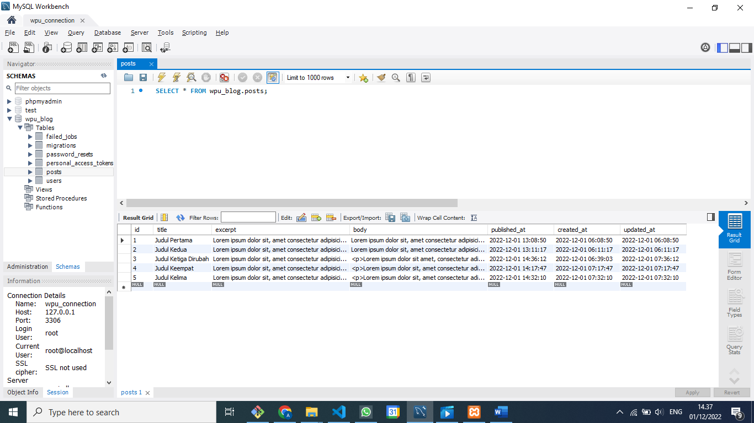

> Post::where('title', 'Judul Kedua')->update(['excerpt'=>'excerpt dirubah'])

= 1

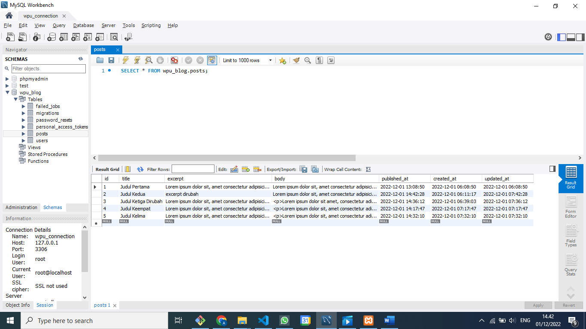

**Route Model Binding**

PostController.php

    public function show($id)

    {

        return view('post', [

            "title" => "Single Post",

            "post" => Post::find($id)

        ]);

    }

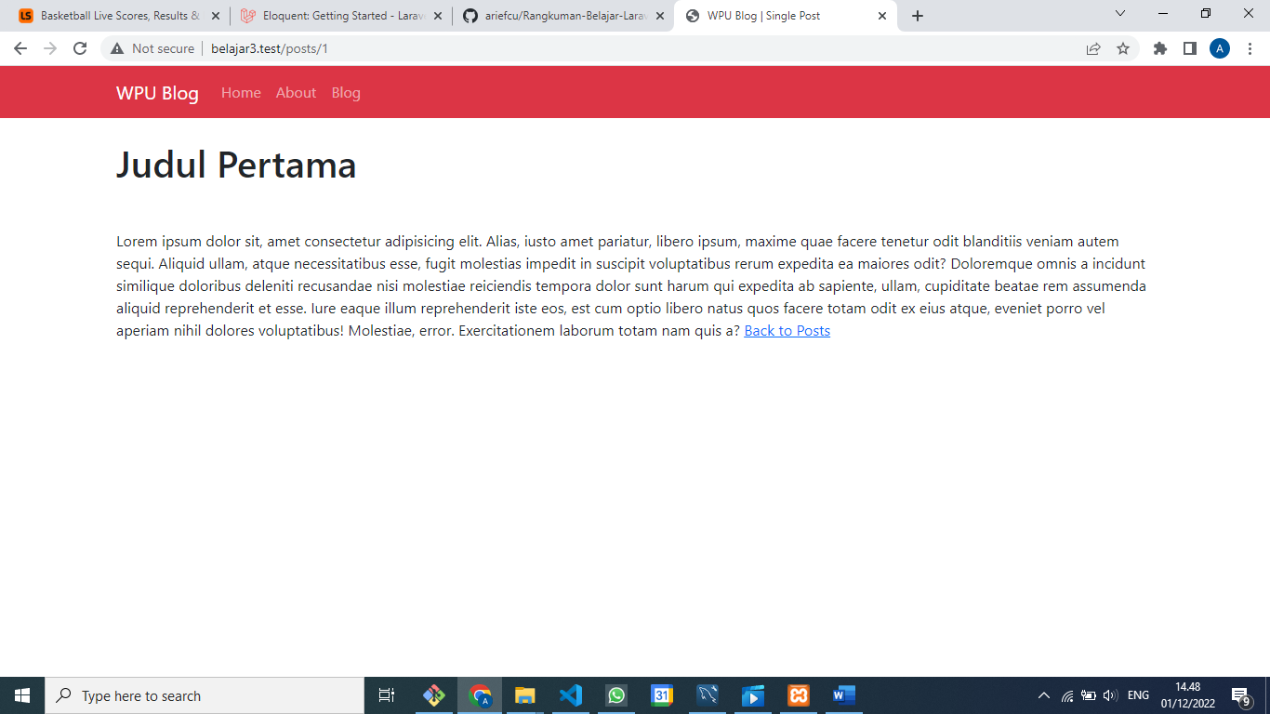

Nambah ini di migrasi :

    public function up()

    {

        Schema::create('posts', function (Blueprint $table) {

            $table->id();

            $table->string('title');

            $table->string('slug')->unique();

            $table->text('excerpt');

            $table->text('body');

            $table->timestamp('published_at');

            $table->timestamps();

        });

    }

Save

KOERNIA DEWATA@IT-SUPPORT MINGW64 /d/applications/belajar3 (main)

$ php artisan migrate:fresh

Dropping all tables .............................................. 65ms DONE

INFO Preparing database.

Creating migration table ......................................... 30ms DONE

INFO Running migrations.

2014_10_12_000000_create_users_table ............................. 33ms DONE

2014_10_12_100000_create_password_resets_table ................... 28ms DONE

2019_08_19_000000_create_failed_jobs_table ....................... 40ms DONE

2019_12_14_000001_create_personal_access_tokens_table ............ 29ms DONE

2022_12_01_043036_create_posts_table ............................. 32ms DONE

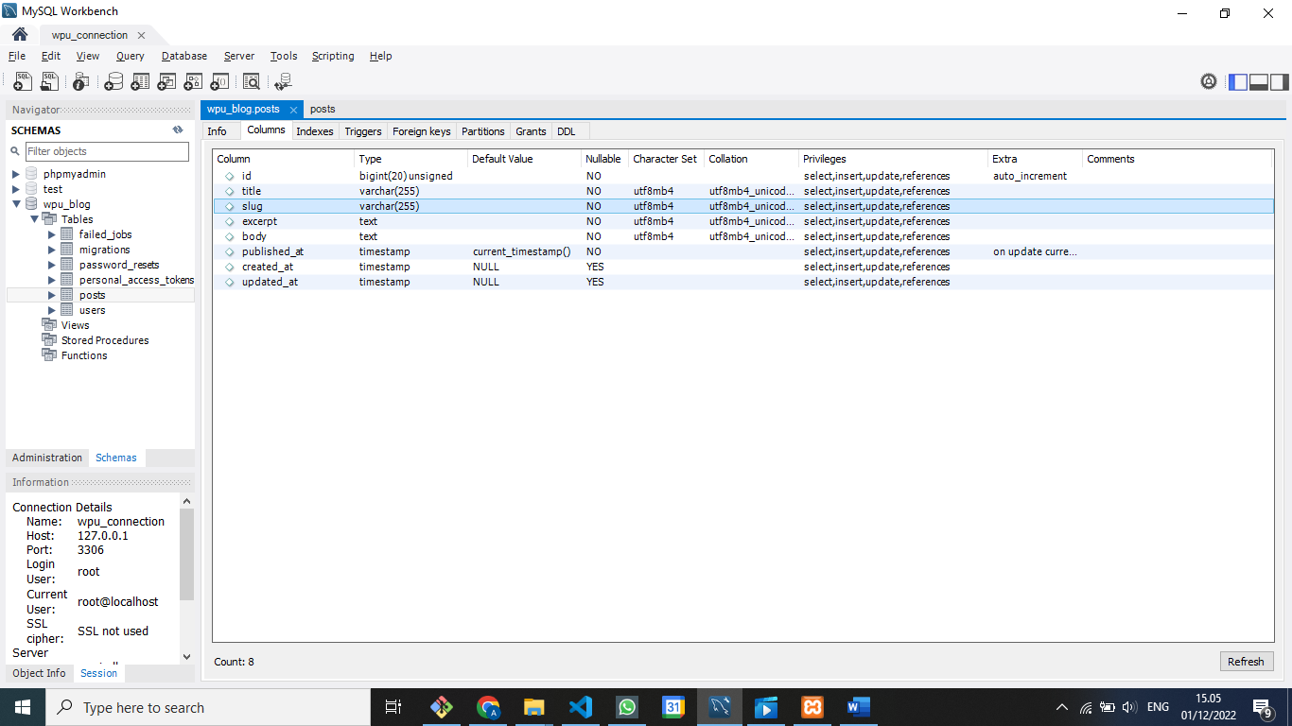

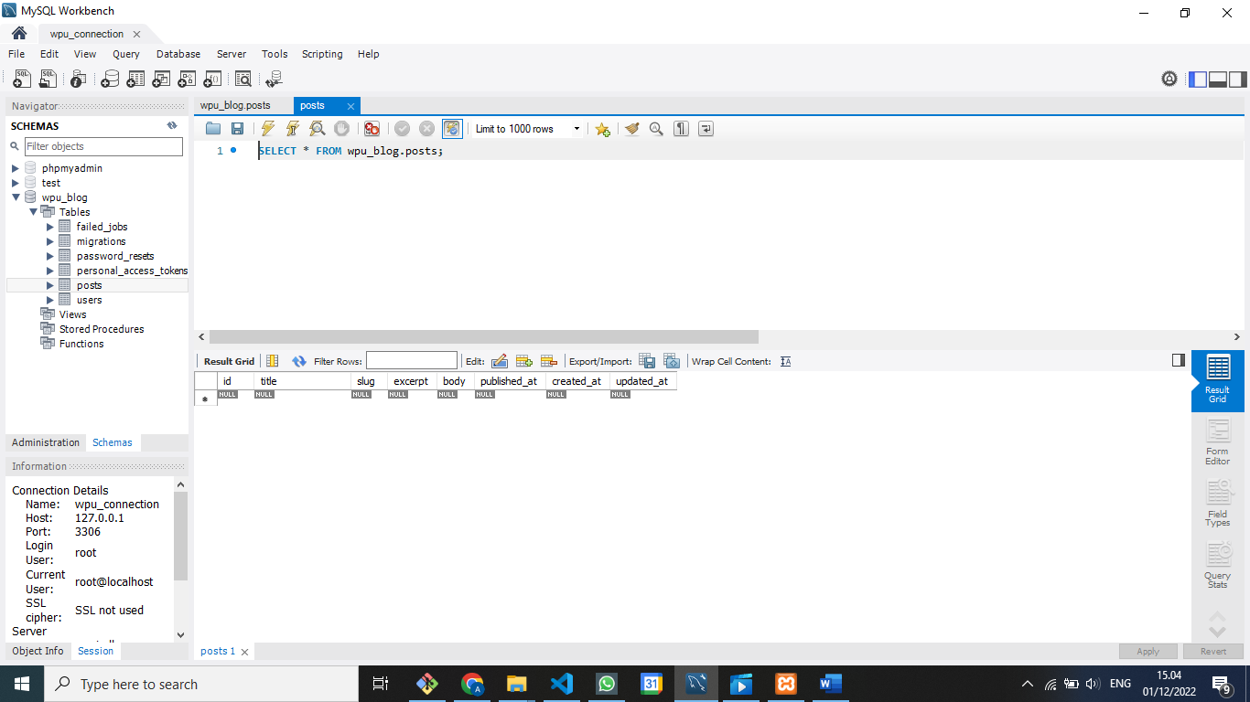

Isi data pakai php artisan tinker

Post::create([

    "title" => "Judul Ketiga",

    "slug" => "judul-ketiga",

    "excerpt" => "Lorem ipsum dolor sit, amet consectetur adipisicing elit. Amet aspernatur ipsam, do loremque voluptatem quis incidunt quasi deleniti officiis cupiditate eligendi similique quos fuga sint error, accusantium suscipit aliquam.",

    "body" => "<p>Lorem ipsum dolor sit, amet consectetur adipisicing elit. Amet aspernatur ipsam, do loremque voluptatem quis incidunt quasi deleniti officiis cupiditate eligendi similique quos fuga sint error, accusantium suscipit aliquam. Dignissimos corporis, dolore ea modi ex, voluptatibus soluta eum n atus, accusantium at id voluptas aperiam maxime assumenda rem. Nesciunt repellendus itaque corrupti nat us sapiente alias fuga facilis consectetur eum. Est, sequi obcaecati. </p><p>Velit provident rem perspi ciatis enim quibusdam hic vero placeat eum, molestias, consequatur quia atque soluta sint labore dolore mque aut? Cum dolore labore ipsa commodi odio explicabo dolor quisquam aliquam esse? </p><p>Sit et id e veniet, officiis aperiam fuga suscipit rerum minus, maxime illum corrupti non ullam enim consectetur to tam accusamus maiores sunt! Repellat aspernatur voluptatem dicta. Esse minus quo ad fugiat corrupti, pe rspiciatis eaque quasi sint dolore maiores fugit sequi facere dolorem animi laborumvoluptatibus numqua m quisquam dolorum temporibus officia nulla nihil est nisi architecto? Ea enim corporis ut facere porro</p>"

])

Di Route web.php

<?php

use App\Models\Post;

use Illuminate\Support\Facades\Route;

use App\Http\Controllers\PostController;

*/\**

*|--------------------------------------------------------------------------*

*| Web Routes*

*|--------------------------------------------------------------------------*

*|*

*| Here is where you can register web routes for your application. These*

*| routes are loaded by the RouteServiceProvider within a group which*

*| contains the "web" middleware group. Now create something great!*

*|*

*\*/*

*// Route::get('/', function () {*

*//    return view('welcome');*

*// });*

Route::get('/', function () {

    return view('home', [

        "title" => "Home"

    ]);

});

Route::get('/about', function () {

    return view('about', [

        "title" => "About",

        "name" => "Arief Cahyo Utomo",

        "email" => "ariefcu@gmail.com",

        "image" => "img/brain.png"

    ]);

});

Route::get('/posts', [PostController::class, 'index']);

Route::get('posts/{post}', [postController::class, 'show']);

Ditambahkan jadi :slug

<?php

use App\Models\Post;

use Illuminate\Support\Facades\Route;

use App\Http\Controllers\PostController;

*/\**

*|--------------------------------------------------------------------------*

*| Web Routes*

*|--------------------------------------------------------------------------*

*|*

*| Here is where you can register web routes for your application. These*

*| routes are loaded by the RouteServiceProvider within a group which*

*| contains the "web" middleware group. Now create something great!*

*|*

*\*/*

*// Route::get('/', function () {*

*//    return view('welcome');*

*// });*

Route::get('/', function () {

    return view('home', [

        "title" => "Home"

    ]);

});

Route::get('/about', function () {

    return view('about', [

        "title" => "About",

        "name" => "Arief Cahyo Utomo",

        "email" => "ariefcu@gmail.com",

        "image" => "img/brain.png"

    ]);

});

Route::get('/posts', [PostController::class, 'index']);

Route::get('posts/{post:slug}', [postController::class, 'show']);

**Laravel 8 : #8 Post Category & Eloquent Relationship**

**Laravel 8 : #9 Database Seeder**

**Laravel 8 : #10 Factory & Faker**

**Laravel 8 : #11 N+1 Problem**

**Laravel 8 : #12 Redesign UI**

**Laravel 8 : #13 Searching & Pagination**

**Laravel 8 : #14 View Login & Registration**

**Laravel 8 : #15 User Registration**

**Laravel 8 : #16 User Login & Middleware**

**Laravel 8 : #17 Dashboard UI**

**Laravel 8 : #18 Create Post Form**

**Laravel 8 : #19 Validation & Insert Post**

**Laravel 8 : #20 Update & Delete Post**

**Laravel 8 : #21 Upload Image**

**Laravel 8 : #22 Preview, Update & Delete Image**

**Laravel 8 : #23 Authorization**

**Laravel 8 : #24 Upload Ke Web Hosting (GRATIS)**